**IMI2 Project 807015 – IM2PACT**

**Investigating Mechanisms and Models Predictive of Accessibility of Therapeutics into the brain**

**WP1: BBB Target Discovery**

# D1.4 BBB disease targets

|  |  |
| --- | --- |
| **Lead contributor** | Caleb Webber, Mateus, Frank Wesley (CU) |
|  |  |
| **Other contributors** | Hannah Sleven, Gabriel Rocha, Ese Iffie, Olaf Ansorge, Zameel Cader (UOXF)  Fiona McLean, Mike Ashford (UNIVDUN)  Maarja Andaloussi Mäe, Christer Betsholtz (UU) |

## Document History

|  |  |  |
| --- | --- | --- |
| **Version** | **Date** | **Description** |
| V1.0 | 01 12 2023 | Deliverable Report |

## Executive Summary

>>Caleb/Mateus

Obesity and type 2 diabetes (T2D) are risk factors for Alzheimer’s disease (AD), however the underlying mechanisms which link these diseases still need to be fully elucidated. Blood-brain barrier (BBB) breakdown and dysfunction occur in T2D as well as early in AD, prior to dementia and neurodegeneration. We used single-cell RNA sequencing to analyse endothelial cell transcriptomes in obese (C57Bl6/J mice fed 60% high-fat diet) and obese with hyperglycaemia (BKS.Cg-Dock7m+/+Leprdb/J) mouse models. We found that obesity caused limited changes to gene expression in brain endothelial cells, however obesity with hyperglycaemia caused more pronounced changes including genes involved in expression networks, including microvessel structure and metabolism, alongside suppression in blood flow and worsened metabolic phenotype. Changes in genes linked to Alzheimer’s disease were also detected.

## Introduction

Knowledge of the gene expression patterns in different cell types within a tissue in health and disease has led to a much greater understanding of the changing cell state, identifying translational opportunities to intervene and modify. Single cell/nuclei transcriptomic sequencing, whereby the variety and abundance of mRNA types within a cell or nuclei is measured, has revolutionised our understanding of how distinct cell types within a tissue function in health and disease. While obtaining the cells of parenchymal brain tissue has been well reported, the cells that constitute the blood-brain barrier (endothelial cells, pericytes, smooth muscle cells) have been subject to much less study. Endothelial cells are universally under-represented in current human transcriptomic single-cell studies (e.g. PMID 31042697, 31768052), likely due to difficulties in freeing nuclei from robust connective tissue as opposed to the parenchyma. In this project, we sought to use single cell approaches to investigate the role of brain vasculature in Alzheimer’s Disease (AD) and Metabolic Disorders that have been considered risk factors for AD.

Although a proportion of AD cases are linked to specific genes (e.g. APP, PSEN1 and 2, APOEε4), most occur sporadically. Sporadic cases are linked to modifiable risk factors, many of which are associated with metabolic dysregulation, including obesity and type 2 diabetes (T2D). Insulin resistance, alongside hyperglycaemia, are key features of T2D, with both frequently occurring in AD patients. Furthermore, there is evidence of metabolic dysregulation in brain microvessels in AD, with reduced expression of the glucose transporter, GLUT1, in ECs as well as decreased brain blood flow. Metabolic dysregulation may be particularly detrimental to brain ECs, as they have a high mitochondria content, and a high energy demand due to their transport functions. Defective mitochondrial respiration has also been linked to AD as Aβ can increase reactive oxygen species, oxidative stress and inflammation. Importantly, obesity and T2D can potentiate these processes, linking metabolic dysregulation to BBB dysfunction and AD causality. Notably, people with T2D have a higher incidence of cognitive decline and are more likely to develop AD. However, we still do not know the underlying molecular changes that occur in obesity and T2D that could lead to BBB breakdown and trigger AD.

## Methods

**Alzheimer’s Disease**

As reported previously, our initial microvessel-enrichment protocol yielded an endothelial cell population representing approximately 4% of all captured nuclei, which were analysed as part of a pilot project including two post-mortem brain tissue samples. Hannah Sleven from the University of Oxford (Zam Cader’s lab) significantly modified and improved the protocol with the aim to yield a higher representation of neurovascular cell types. UOXF followed up on the successful development of the Vascular/Endothelial nuclei isolation protocol in the previous reporting period with critical methodological and logistical improvements. The key additional feature of the resultant protocol, NeuroV-seq (Figure 1), is the simultaneous isolation of separate vascular and parenchymal nuclei fractions from the same starting brain tissue whilst retaining the outstanding vascular purity achieved in the initial method. Technical improvements utilised novel 3D design and printing to achieve a shorter protocol duration and higher reproducibility.

The NeuroV-seq protocol was used on a large (20 control, 20 Alzheimer’s cases) cohort to generate novel and crucial data on properties of the vasculature and parenchyma in health and disease. Tissue identification and supply and the tissue and nuclei processing was conducted by UOXF and the bioinformatic analysis by our partners in UCAR.

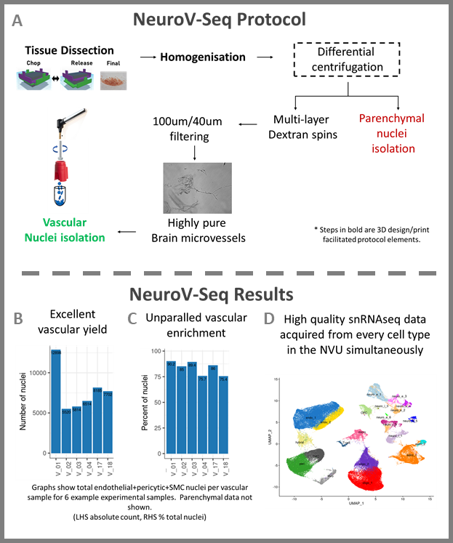

**Figure 1: Overview of the NeuroV-seq protocol** (A), and example results of vascular nuclei yield (B) and enrichment (C). UMAP Plot (D) verifies capture of all the major brain cell types using NeuroV-seq protocol.

An overview of the method is given in Figure 1. We identified poor removal of meningeal tissue, poor control of dissection and loss of valuable tissue mass when traditional 4⁰C dissection of brain tissue was performed. Meningeal contamination and poor dissection control was particularly detrimental to high yield vascular nuclei recovery. We developed a simple holding unit to enable dissection whilst maintaining tissue temperature at ~-80C outside of the freezer allowing, careful removal of meninges and other contaminants. We further created a 3D printed tissue chopper to perform rapid and precise dissection of ultra-cold frozen tissue from solid brain matter into a coarse powder optimal for nuclei isolation, which can then be stored at -80⁰C until the day of isolation. Brain vessels are typically lost in standard isolation protocols through under- or over-homogenisation. Our homogenisation procedure enables thorough release of vessels whilst minimising vessel damage. It utilises a 3D printed pestle to allow large-volume pestle-driven homogenisation. Multiple rounds of homogenisation and low speed centrifugation remove released vessels as homogenisation of tissue progresses (Fig 1B) and finally isolate incompletely homogenised tissue for Dounce homogeniser vessel release. Subsequent low-speed centrifugation steps segregate the vessels from the tissue homogenates at which point the vessel-free supernatant is removed for parenchymal isolation. The vascular pellets are then further processed for nuclei isolation. Purification of the vascular fraction begins with two multi-layer dextran gradient centrifugation steps using a standard refrigerated laboratory centrifuge. The density interfaces trap contaminants whilst allowing vascular transfer, greatly outperforming a single gradient approach. Filtering the resulting vessel suspension through a 100um nylon filter removes unwanted larger vessels, and vessel capture on 40um PET filters allows depletion of residual contaminating particles.

Purified vessels are then transferred onto 20um PET filters for digestion and nuclei isolation. First collagenase II digestion at 4⁰C permeabilises the basement membrane of the vasculature. After the enzyme and released final debris are removed with a wash step, the 20um filter is placed into the 3D printed funnel assembly (supp Fig x ) and a hand-held homogeniser is used with a 3D printed flat base pestle to grind the nuclei out of the vessels which are then captured by flushing through to a tube. Nuclei after staining with DAPI are isolated using FACS. The parenchymal supernatant extracted previously is processed to nuclei using standard protocols and similarly FACS isolated. Extracted and isolated nuclei can then be used with the single-nuclei RNA-seq platform of choice (here 10x Genomics) for transcriptomic analysis Our protocol provides extensive coverage of all four major vascular cell types (endothelial, pericyte, smooth muscle cell (SMC), fibroblasts) and their neighbouring parenchymal cells (astrocytes, microglia, excitatory neurons, inhibitory neurons, oligodendrocytes, oligodendrocyte precursor cells (OPC)). Additionally vascular-associated microglial populations and both vascular and parenchymal T-Cell populations are isolated during the procedure. Our vascular isolation captures the vasculature at a mean purity of 93% with a predominantly capillary population of endothelial cells and mural cells. Thus, the isolation method simultaneously captures every brain cell type and constitutes both the first high purity vascular isolation and the first high-yield whole-brain nuclear isolation protocol. For the first time it allows detailed examination of the vasculature and whole-tissue brain transcriptomics analyses.

We received the single nuclei sequencing and genotype data for the final 20 donors in 2023 for this project, bringing the total to 40 donors (20 cases/ 20 controls), each with separate parenchymal and vascular fractions separately for a total of 80 samples sequenced. All data has been reprocessed with updated reference genomes to maintain consistency across all three sequencing batches.

FastQC/MultiQC were run to assess sequencing quality, no issues were found with the latest batch of samples. Subsequently standard processing was done with cellranger, using an updated reference with Ensembl version 109 and Gencode version 43. The output of this was run through scFlow with standard parameters which was then read into R via the Seurat package.The read counts and number of features output from scFlow revealed that 3 of the donors, and the vascular fraction from a fourth donor, were of poor quality and so they were excluded from downstream analysis. The final set of nuclei showed highly comparable reads and gene counts per nuclei were obtained from both parenchymal and vascular fractions and between AD cases and controls (**Figure 2**). Three donors and the vascular fraction of a fourth donor did not pass QC checks and so were excluded. The cell types (both high level and subtypes) were then manually annotated based on cluster markers and concordance with existing literature, though no other papers have gotten a comparable level of enrichment for these cell types (Figure 3) (Yang et al. 2022).



Figure 2: Mapped reads (right) and gene counts (left) per nuclei are highly similar between both the parenchymal and vascular nuclei fractions and between AD cases (red) and controls (green).

**Rodent Models**

Prior to carrying out single-cell RNA sequencing on brain endothelial cells, mouse models underwent metabolic phenotyping:

* C57Bl6/J mice fed a high-fat diet (60% kcal from fat for 16 weeks vs chow-fed controls):
* Increased body weight
* Increased fat mass
* Mildly hyperglycemic
* No differences insulin levels in blood
* Elevated leptin levels in blood
* Moderately restricted peripheral blood vessels, but intact response to vasodilatory compounds.
* Moderately restricted brain blood vessels, but intact autoregulatory response to physical stimulus. No change in exchange levels of oxygenated and deoxygenated haemoglobin.
* Extracted microvessels show reduced overall cellular respiration, including a reduced basal oxygen consumption rate and reduced non-mitochondrial respiration.
* BKS.Cg-Dock7m +/+ Leprdb/J (Db/Db mice vs Wt/Db controls):
* Increased body weight
* Increased fat mass
* Severely hyperglycemic
* Increased insulin levels in blood
* Substantially elevated leptin levels in blood
* Substantially restricted peripheral blood vessels, with reduced response to vasodilatory compounds.
* Substantially restricted brain blood vessels, with impaired autoregulatory response to physical stimulus. Decreased exchange levels of oxygenated and deoxygenated haemoglobin.
* Extracted microvessels show reduced overall cellular respiration, including a reduced basal oxygen consumption rate and reduced non-mitochondrial respiration, as well as decreased maximal respiratory capacity and ATP-linked respiration.

Preparation of Single-Cell Suspension

* Brains were dissected and the olfactory bulbs and cerebellum were removed and discarded. The brain was then rolled on filter paper to remove large surface vessels. The MACS Miltenyi Biotec protocol for ‘Isolation and cultivation of endothelial cells from adult mouse brain’ with some modifications which as outline on Protocol Exchange. Once the cells were collected, the solutions were passed twice through Flowmi ® 40um cell strainers for pipette tips. Cells were counted using a hemocytometre.

Single-Cell Workflow

* The 10X Chromium Next GEM Single Cell 3’ GEM, Library & Gel Bead Kit (v3.1 Chemistry) workflow was followed. Libraries were sequenced on an Illumina X with 40,000 reads per cell. 10X Genomics CelRanger software was used to generate gene expression matrices. The matrices were read into R (v4.2.1) with the following analyses carried out using Seurat package. Seurat Objects were created with thresholds of ≥3 cells and ≥200 features. Filtering of data was performed to remove low-quality cells by detecting cells with high numbers of mitochondrial transcripts (>15%) and low (<200) or high (>7500) number of uniquely expressed genes. Data normalisation was applied using the NormalizeData() function and the top 2000 most variable features were found using the FindVariableFeatures() function. Data scaling was performed using ScaleData() function and the first 32 principal components were calculated using the RunPCA() function. Clustering was carried out using the functions RunUMAP(), FindNeighbors() and FindClusters(). Data sets from individual mice were then integrated using FindIntegrationAnchors() and IntegrateData() and the combined data set then had ScaleData(), RunPCA(), RunUMAP(), FindNeighbors() and FindClusters applied. The top 10 expressed genes in each cluster were identified using FindAllMarkers(). A low-quality cluster was identified as it only showed 5 expressed genes and was therefore removed. The combined data set was then re-processed through ScaleData(), RunPCA(), RunUMAP(), FindNeighbors(), FindClusters() and FindAllMarkers().

Cell Clustering and Identification

* Clusters were identified based on the top 10 expressed genes for each cluster (Figure X) alongside the following screened markers: Endothelial cells (ECs) were identified by *Pecam1*, *Cldn5*, *Cdh5* (ECs), with all clusters identified as ECs classed as a single cluster for further downstream analyses.

Differential Gene Analysis

* Differentially expressed genes (DEGs) were generated using FindMarkers() function with ROC test applied. Significant DEG were identified with the selection criteria of an adjusted *p*-value (Benjamini-Hochberg correction) of <0.05 (expressed on a -log10 scale), a |log2(FC)| value of >0.2 and in a minimum of 25% of the cell population from either the condition or control group. Gene functions defined using GeneCards (<https://www.genecards.org/>) and UniProt (https://www.uniprot.org/).

GO Analysis

* GO pathway analyses were performed using String Db (https://string-db.org) using gene list from DAG analysis.

## Results

**Alzheimer’s Disease**

PCA was performed and 35 dimensions were used to find nearest-neighbours and a resolution of 0.6 was used to find clusters via Seurat. UMAP was computed with the same 35 dimensions. Cluster markers were found using genes with at least 20% of cells in a cluster expressing them, and a minimum log foldchange of 0.5, again via Seurat (**Figure 3**).

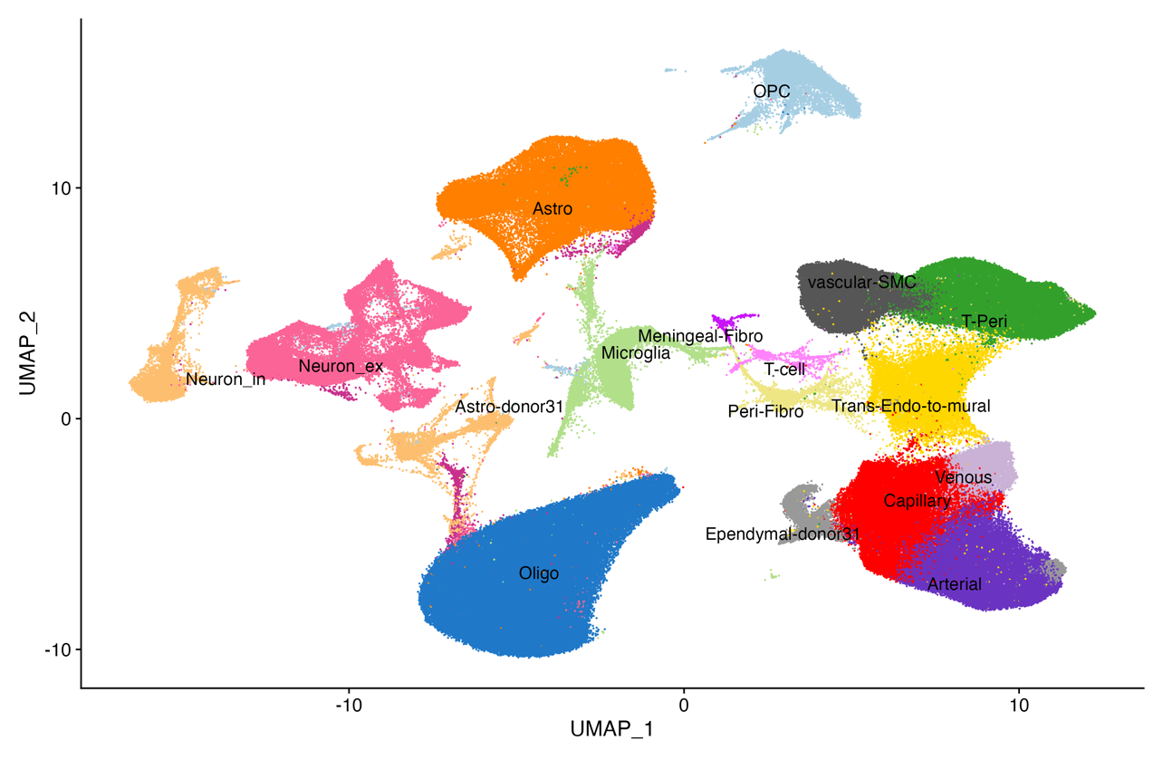**Figure 3:** A UMAP of the sequencing data with manual annotations of cell types. Note that there are more granular subtype annotations in Figure 4 that are not shown here in the interest of visual clarity.

Differences in cell type proportions between cases and controls were examined with the speckle R package. It leverages biological replication to obtain measures of variability of cell type proportion estimates and uses empirical Bayes to stabilize variance estimates by borrowing information across cell types.

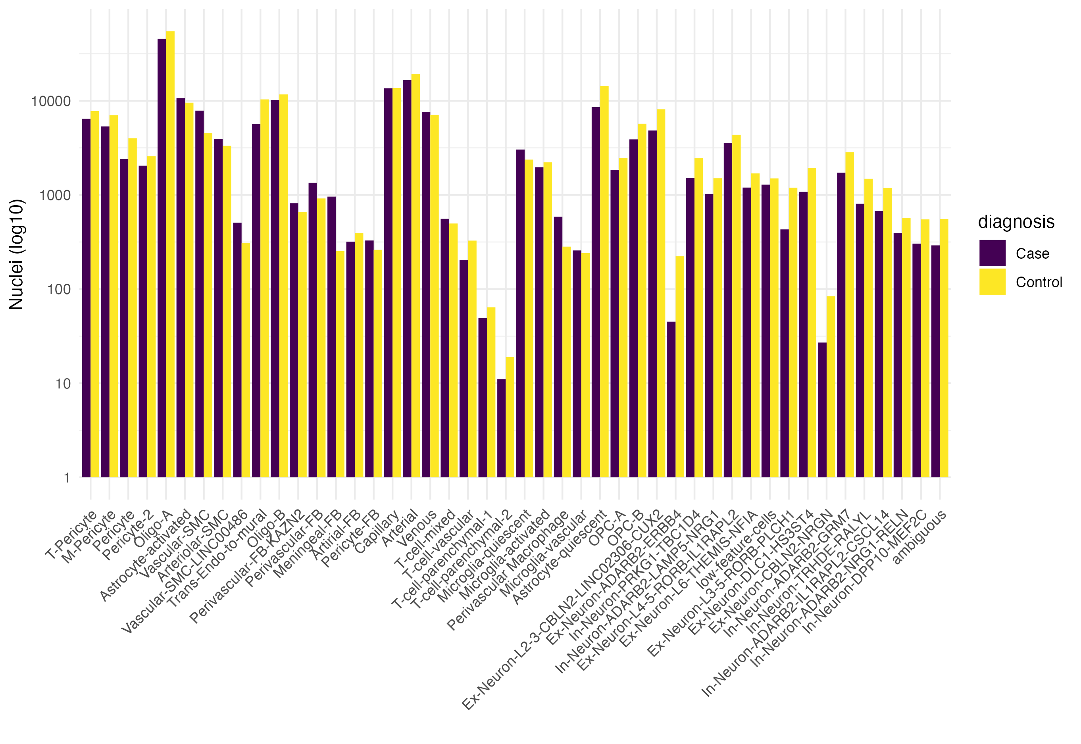

Figure 4: Nuclei counts per cell-type for AD and control groups.

**The role of the brain vasculature in the risk of Alzheimer’s disease**

To address the question of the role of vascular and parenchymal cell types in the manifesting the genetic risk of AD, we used a classical analyses examining the location of cell type-specific genes within regions of the genome associated with the genetic risk of AD. Defining cell type-specifically expressed genes requires a knowledge of which genes are expressed to what level across different cell types, and thus is completely dependent upon the range of cell types considered. Our novel approach to obtaining vascular and parenchymal cells from the same brain tissue enables the most complete picture of cell type expression of genes within the human prefrontal cortex and thus the most accurate picture of cell type specificity. Using only nuclei from control samples, every gene was assigned a cell type specificity for each of the 43 defined cell types defined as the p-value from a Wilcoxon rank sum test p-value calculated for that gene’s expressions in a specified cell type against that genes expression across all other cell types. Genes were then ranked for each cell type and the top 5% of genes in each ranking used to define the set of cell type-specific genes for that cell type. Each set of cell -type specific genes was then examined using MAGMA for an association with Alzheimer’s disease risk, where Alzheimer’s disease risk was defined using summary p-values derived from (Bellenguez et al. 2022) (**Figure X**). We repeated defining cell type specificity considering only 19 vascular-fraction cell types and also considering only the 22 parencymal cell types. The results show that the method of defining the window size around AD risk loci play a critical role in defining the disease association. When cell type specificity across all cell types is considered, there is a significant association between AD genetic risk loci and genes expressed specifically in Arteriolar smooth muscle cells or in perivascular cells (**Figure 5**). However, genetic risk variants may lie within regulatory elements for genes nearby and thus sequence upstream and downstream of a gene which is likely to contain regulatory sequence for that gene is often also considered as part of that gene. When this additional sequence is included, there is a clear association specifically with genes specifically expressed in activated microglia (**Figure 5**). However, the AD risk cell type associations differ when considering only parenchymal cell types. Irrespective of the definition of the gene sequence, genes specifically expressed in quiescent microglia are associated with the genetic risk of AD. When considering only the vascular cell types when defining cell type specificity, none of the vascular cell types are significantly associated with AD genetic risk (**Figure 5**). These results illustrate that these genetic risk/cell type associations are dependent upon (i) the statistical definitions of cell type specificity, (ii) the sequence defined as associated with a given gene and (iii) the cell types used in defining cell type specificity. The exact gene networks underlying the associations detected need to be further elucidated but we note that several studies using less complete data sets have significantly associated microglia specific gene expression with AD genetic risk.



Table 1: Gene expression changes between AD and controls across cell types.

**Changes in the brain vascular in the progression of Alzheimer’s disease.**

We next turned to examine changes in the prefrontal cortex vasculature during Alzheimer’s disease. Examining the 20 cases and 20 controls who prefrontal cortex tissue had been sequenced, we looked for changes in the proportions of the cell types identified in each fraction. Across all cell types, we found only 3 that had significant changes in proportion with Alzheimer’s. In the parenchymal fraction, we identified a decrease in two populations, the *Ex-Neuron-ADARB2-ERBB4* and the *Ex-Neuron-L3 5-RORB-PLCH1* excitatory neurons (**Figure 6**). The loss of these two neuronal subtypes in Alzheimer’s disease matches previously published analyses reporting the loss of these two neuronal populations, corroborating our single cell approach here (REF). In the vascular fraction, we found only a decrease in the *Trans Endo-to-Mural* population in Alzheimer’s disease (**Figure 6**). There is little known about this cell type in the neurovasculature but the gene markers of this cell population match those of mouse endocardial endothelial cells which are reported to be progenitors of pericytes and vascular smooth muscle cells in the murine embryonic heart (Chen et al. 2016). In the mouse, endocardial cells undergo endothelial–mesenchymal transition and convert into primitive mesenchymal progenitors that migrate into the myocardium, differentiate and assemble the wall of coronary vessels. Assuming the role in the mouse myocardium are maintained in the human neurovascular, the apparent decrease of the *Trans Endo-to-Mural* population in Alzheimer’s disease could indicate deficits in the maintenance of the brain’s blood vessels.

We next turned to examine the changes in gene expression in each cell type. For this, we grouped the 43 cell types (**Figure 4**) into their overarching cell classifications and looked for changes in gene expression. While we observed a large number of differentially expressed (DE) genes within the parenchymal populations, most notably amongst astrocytes, we found more modest changes amongst three neurovascular cell types, namely endothelial cells (18 DE genes), pericytes (76 DE genes) and Trans Endo-to-Mural cells (28 DE genes) (**Table 1 & Table 5**). In order to examine the underlying functions associated with these genes, we identified significantly enriched Gene Ontology terms for each vascular DE gene set (**Figure 7**). The upregulated DE genes in the pericytes are enriched in vascular development. Drawing again from the mouse cardiovascular studies, pericytes form the progenitors for artery smooth muscle (Volz et al. 2015) and thus this expression may indicate the instigation of neurovascular repair processes, which fits with our observed changes in the Trans Endo-to-Mural cell population described above. Both the endothelial cells and the Trans Endo-to-Mural cell population upregulate genes involved in the cellular response to peptide hormones….. All three cellular populations downregulate genes associated with tRNA processing which suggests an increase in translational regulation in these cells during Alzheimer’s.

**Changes in IM2PACT candidate blood-brain-barrier transporters during Alzheimer’s disease.**

For Deliverable 1.1, by combining unpublished endothelial data produced by the IMI COMPACT with single cell mouse RNAseq data from the Betzholts group and refining through functional genomics, we identified 9 candidate transporters, namely APCDD1, ATP10A, ELOVL7, LRRN3, PROM1, SEMA7A, SLC16A4, SLC3A2 and SLC7A1. Of these, pilot human neurovascular singled out ATP10A, ELOVL7 and SLC7A1 as being specifically expressed in neurovascular cell types (**Figure 8**) and thus became the subject of further investigations by the IM2PACT consortium efforts. The utility of these candidate transporters for delivery of any therapeutic agent for AD could be severely affected by the transporter’s expression during AD and the availability of our larger set of controls along with AD cases enabled us to examine the expression of ATP10A, ELOVL7 and SLC7A1 during the disease. Expression analyses of these three candidate transporters revealed that their expression was largely unaltered in the Alzheimer’s cases as compared to controls (**Figure 9**) and thus they remain attractive candidate transporters for AD therapeutics.

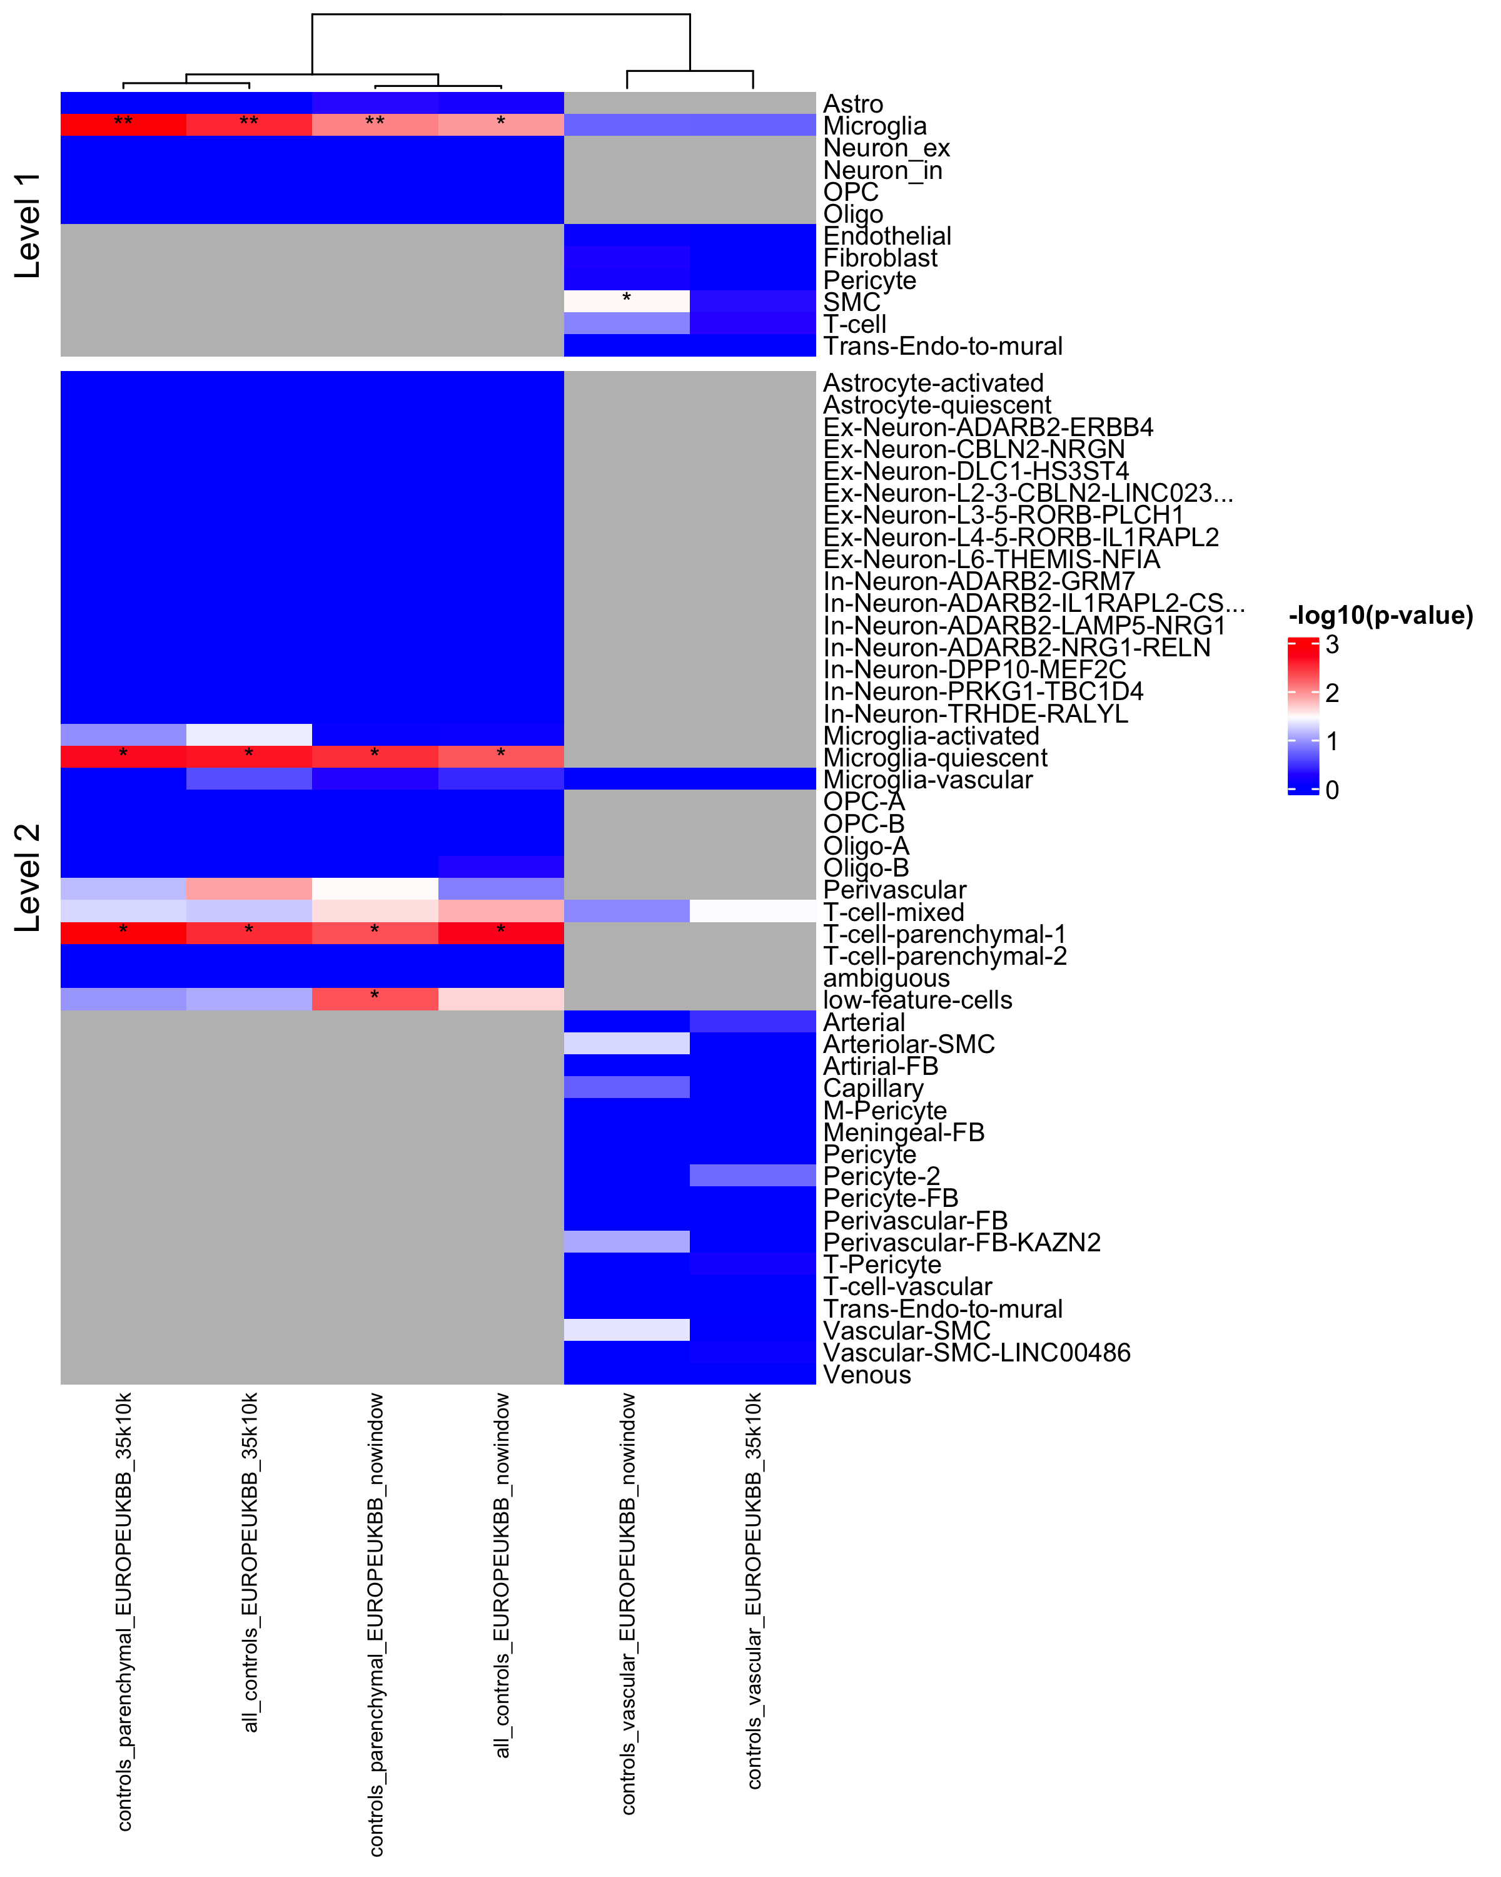

Figure 5. Heatmap of -log10 adjusted p-values of celltype associations with Alzheimer’s disease risk. Derived from MAGMA scores using the Bellenguez et al. 2022 GWAS summary statistics. Celltype gene lists were created for all control nuclei, the control parenchymal nuclei and the control vascular nuclei fractions seperately. The SNP-gene annoation was perfomed with and without a 35/10 kilobase window around the gene. Celltype marker genes were selected by considering genes expressed in at least 25% of nuclei in that celltype contrasted against all other nuclei via a Wilcoxon Rank Sum test. The resultsing top 1000 genes ranked by adjusted p-value were selected as celltype marker genes.

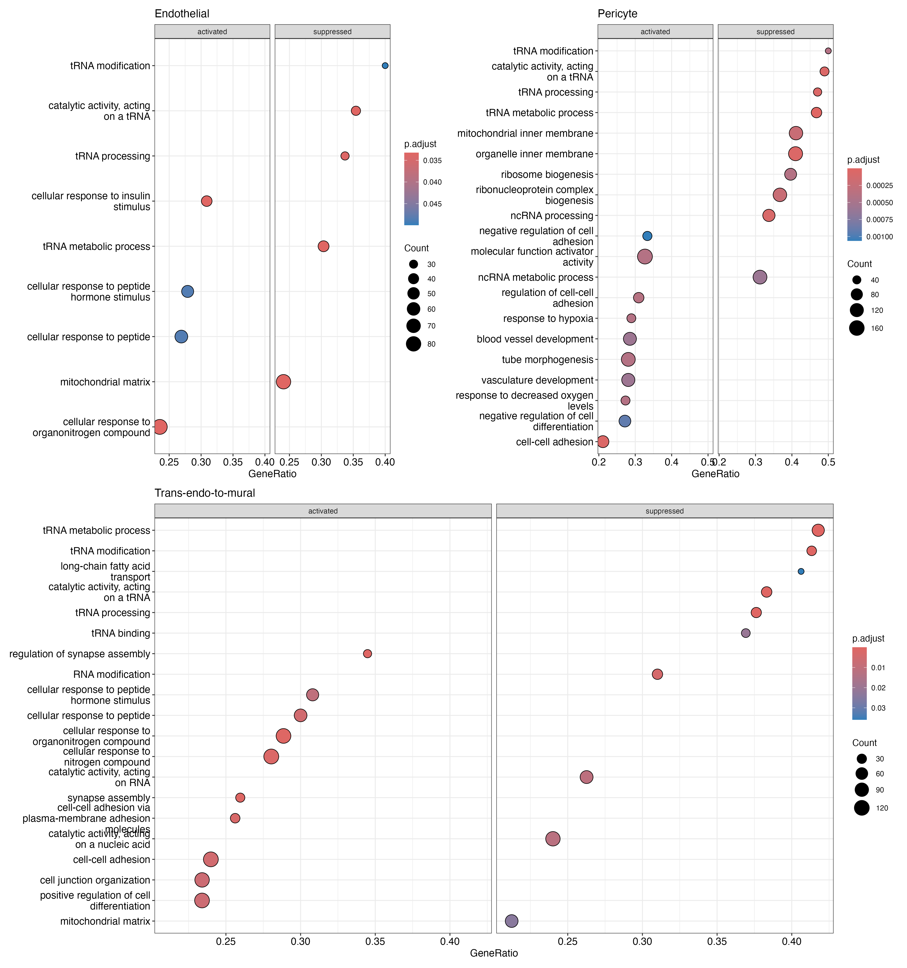

Figure 7: Gene Set Enrichment Analysis (GSEA) GO term associations derived significant pseudobulk differentially expressed genes between cases and controls. The vascular cell types are highlighted here.



Figure 6: Significant differences in proportions were observed between only 3/43 cell types between AD (case) and controls, specifically for the Trans Endo-to-Mural cells within the vascular fraction and for two types of excitatory neurons within the parenchymal fraction. Speckle R package, p adj < 0.05.

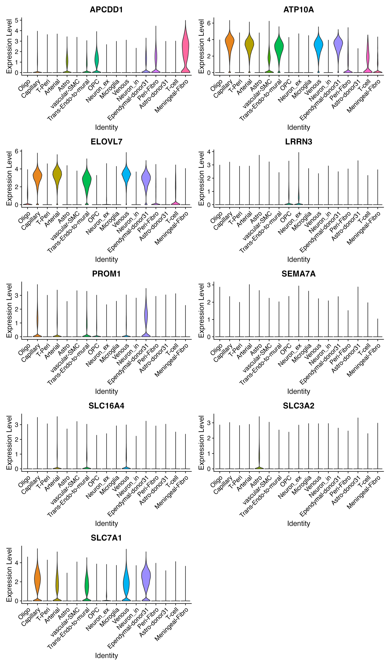

**Figure 8: Expression profile of candidate blood brain barrier transporters across cell types.**

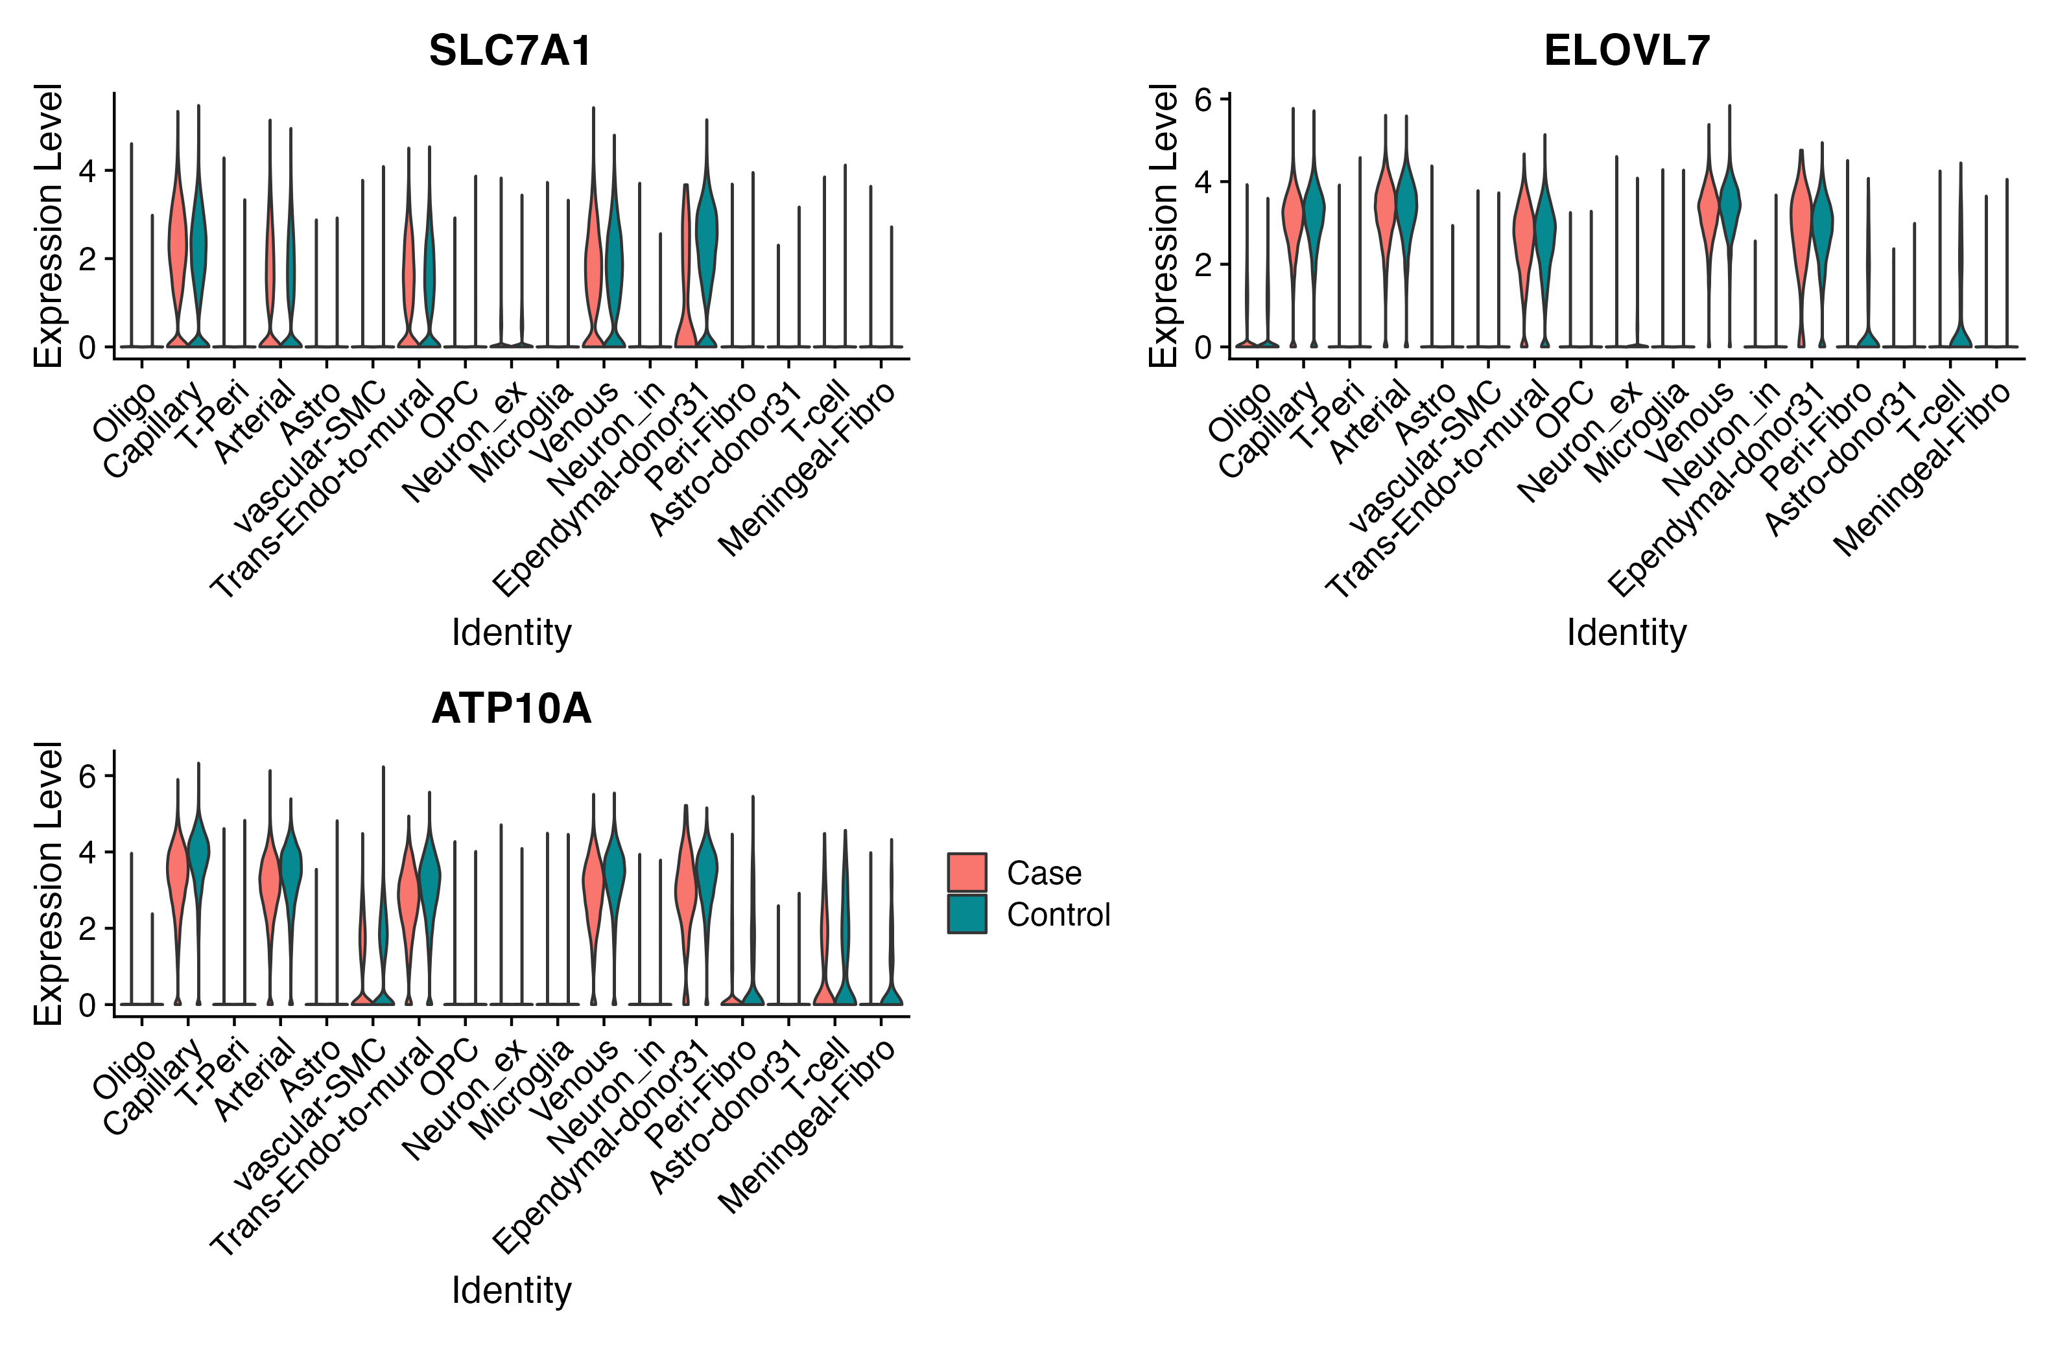**Figure 9: Expression profile of promising candidate blood brain barrier transporters in level 1 cell types across cases and controls.**

**Rodent Models of Metabolic Disorders**

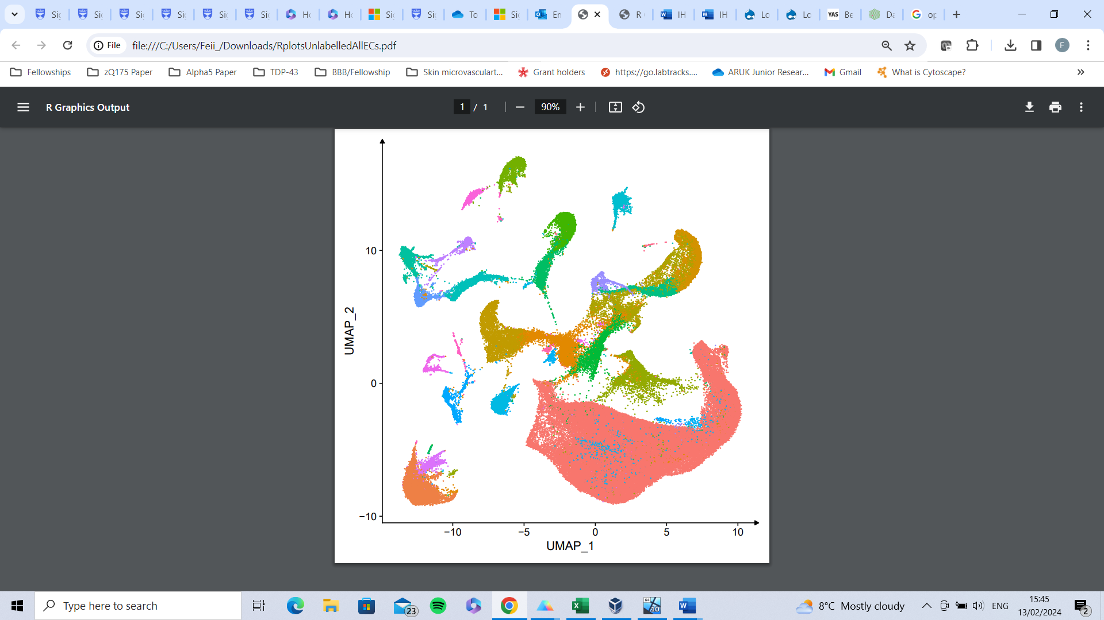

**Endothelial Cells**

Figure 10. Single-cell analyses of blood-brain barrier cells in mouse models of obesity and obesity with hyperglycaemia. Uniform manifold approximation and projection (UMAP) clustering of BBB and associated cells from all 4 conditions. Each point denotes a single cell. Red labelled cell group are endothelial cells carried forward for further analyses. Chow =5, High-fat diet=4, Wt/Db n=5, Db/Db=5.



Table 2. Genes with changed expression from DAG analysis of endothelial cells in obese high-fat diet fed mice.





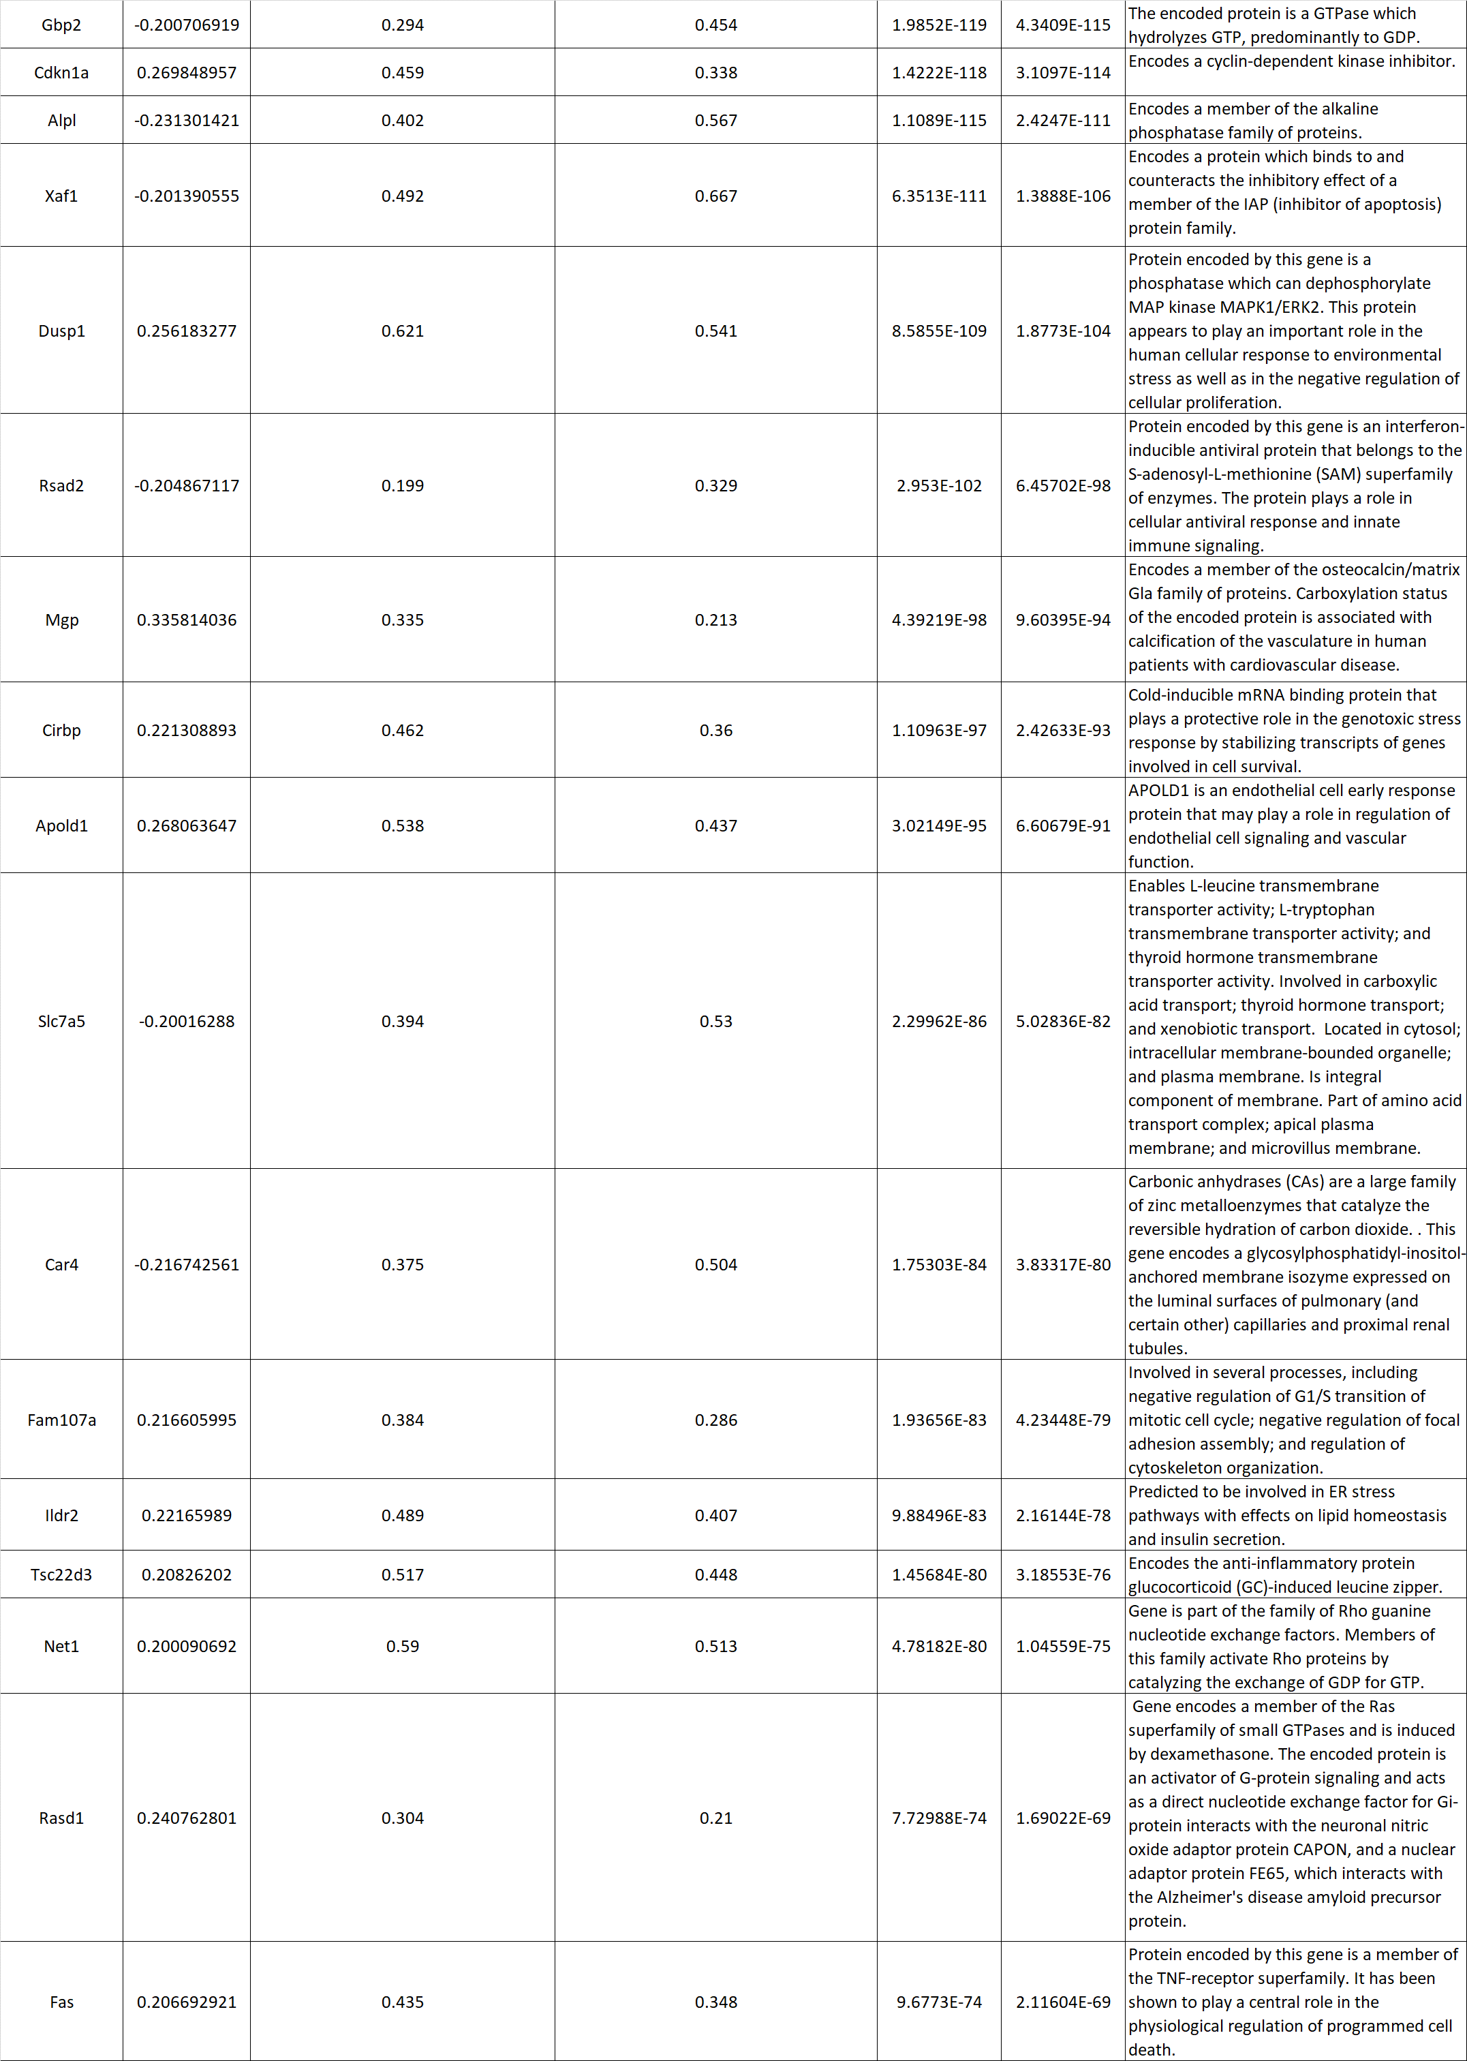



Table 3. Genes with changed expression from DAG analysis of endothelial cells in in obese and hyperglycaemic Db/Db mice.



Table 4. GO pathway analyses of biological processes which changed genes in obese and hyperglycaemic Db/Db mice are involved in.

|  |  |  |  |  |
| --- | --- | --- | --- | --- |
| gene | log2FoldChange | padj | celltype | deg_direction |
| STAU2 | 0.69032851 | 0.04329331 | Arterial | Up |
| UBC | -1.1616298 | 0.04361558 | Arterial | Down |
| ZNF274 | -0.405383 | 0.02570881 | Arterial | Down |
| CD34 | 0.74054709 | 0.04329331 | Arterial | Up |
| AKR1C3 | 1.49817035 | 0.04329331 | Arterial | Up |
| LINC00472 | 0.5872687 | 0.04329331 | Arterial | Up |
| DENND11 | 0.31993407 | 0.04329331 | Arterial | Up |
| LINC02767 | 1.60762128 | 0.02169284 | Arterial | Up |
| PPP5C | -0.5370492 | 0.00582003 | Arteriolar-SMC | Down |
| EEPD1 | -0.7222064 | 0.00582003 | Arteriolar-SMC | Down |
| ZIC1 | 0.62794116 | 0.01979804 | Arteriolar-SMC | Up |
| RANBP3L | 1.18498196 | 0.00582003 | Arteriolar-SMC | Up |
| LINC00472 | 0.63230453 | 0.01979804 | Arteriolar-SMC | Up |
| CYFIP1 | 0.60382438 | 0.03551457 | Arteriolar-SMC | Up |
| FKBP4 | 1.66516454 | 0.03911484 | Capillary | Up |
| AKAP11 | -0.3722363 | 0.01567212 | Capillary | Down |
| MFAP3 | 0.8911617 | 0.0252093 | Capillary | Up |
| STAU2 | 0.83670225 | 0.00254672 | Capillary | Up |
| ZFAT | 0.51308277 | 0.01567212 | Capillary | Up |
| ATP1B3 | 0.73630607 | 0.01884295 | Capillary | Up |
| SREBF1 | 0.69702923 | 0.03184657 | Capillary | Up |
| SYNJ2 | 1.03965385 | 0.00203084 | Capillary | Up |
| EPB41L2 | 0.54483623 | 0.00339687 | Capillary | Up |
| ZBTB25 | -0.4491997 | 0.04948815 | Capillary | Down |
| DEPDC5 | 0.25264166 | 0.0350191 | Capillary | Up |
| PABPC1L | 0.93213912 | 0.01567212 | Capillary | Up |
| ATP11C | 0.66827918 | 0.0451682 | Capillary | Up |
| CDK2AP1 | 1.13336995 | 0.0451682 | Capillary | Up |
| KAT2B | 0.73220942 | 0.00339687 | Capillary | Up |
| KLHL24 | 0.46296099 | 0.01567212 | Capillary | Up |
| PGF | 1.79920963 | 0.01567212 | Capillary | Up |
| BBOF1 | -0.8288892 | 0.03111184 | Capillary | Down |
| NEK9 | -0.3623659 | 0.03911484 | Capillary | Down |
| RHOJ | 0.92991882 | 0.01062738 | Capillary | Up |
| KDR | -0.657501 | 0.0451682 | Capillary | Down |
| CALU | 0.42768695 | 0.04586441 | Capillary | Up |
| ZSWIM4 | 0.90033031 | 0.03543268 | Capillary | Up |
| NAV1 | 0.70528455 | 0.01487056 | Capillary | Up |
| RBM17 | 0.5104154 | 0.01567212 | Capillary | Up |
| SLC43A3 | 1.47090209 | 0.03045498 | Capillary | Up |
| DYSF | 1.10782722 | 7.32E-04 | Capillary | Up |
| RAPGEF5 | 1.03276232 | 0.00287142 | Capillary | Up |
| RAC1 | -0.4546046 | 0.00254672 | Capillary | Down |
| TMEM8B | -0.8130366 | 0.01567212 | Capillary | Down |
| MMRN1 | 2.34867903 | 0.01062738 | Capillary | Up |
| CCNG2 | 1.09177219 | 0.01231426 | Capillary | Up |
| AEBP2 | 0.46107692 | 0.01567212 | Capillary | Up |
| ITGA10 | 1.06271266 | 0.01884295 | Capillary | Up |
| INTS7 | 0.35365035 | 0.03965418 | Capillary | Up |
| ADIRF | -0.9611788 | 0.01062738 | Capillary | Down |
| SESN3 | 0.96578735 | 0.0245556 | Capillary | Up |
| AMN1 | 0.47743317 | 0.01884295 | Capillary | Up |
| PDE6D | 0.48218312 | 0.019565 | Capillary | Up |
| PLSCR2 | 2.00550735 | 0.01231426 | Capillary | Up |
| CREBRF | 0.27924611 | 0.03184657 | Capillary | Up |
| ZHX1 | 0.30976609 | 0.0245556 | Capillary | Up |
| E2F7 | 3.58686211 | 0.01487056 | Capillary | Up |
| EEIG1 | 0.76459942 | 0.0140049 | Capillary | Up |
| ZNF226 | -0.6257907 | 0.0097319 | Capillary | Down |
| PPM1D | 0.41815318 | 0.00287142 | Capillary | Up |
| ZNF483 | -0.663454 | 0.00339687 | Capillary | Down |
| FAM241A | 0.70704581 | 0.03911484 | Capillary | Up |
| TMTC2 | 0.69852315 | 0.01487056 | Capillary | Up |
| SLC36A4 | 0.56633521 | 0.04768694 | Capillary | Up |
| ZNF93 | 0.87634443 | 0.04865675 | Capillary | Up |
| ZNF544 | -0.4836176 | 0.03171216 | Capillary | Down |
| LINC02937 | 0.83601278 | 0.03184657 | Capillary | Up |
| LINC01619 | 1.13011119 | 0.01767132 | Capillary | Up |
| LINC02516 | 1.44111811 | 0.0245556 | Capillary | Up |
| LINC02767 | 1.30469539 | 0.02925912 | Capillary | Up |
| AKAP11 | -0.4417882 | 0.04355132 | M-Pericyte | Down |
| SLC4A11 | 2.53505035 | 0.00256193 | M-Pericyte | Up |
| SRPX2 | 1.51172563 | 0.02963846 | M-Pericyte | Up |
| CCN4 | 1.61475606 | 0.03129891 | M-Pericyte | Up |
| TTLL5 | 0.56754577 | 0.00867896 | M-Pericyte | Up |
| ATXN10 | 0.37231389 | 0.03192593 | M-Pericyte | Up |
| GPR161 | 0.84014742 | 0.0148171 | M-Pericyte | Up |
| CNTN4 | 0.40280385 | 0.01133262 | M-Pericyte | Up |
| C7orf50 | 0.99039921 | 0.01196244 | M-Pericyte | Up |
| PLOD2 | 1.00537997 | 0.04355132 | M-Pericyte | Up |
| RANBP3L | 1.12189026 | 0.02794508 | M-Pericyte | Up |
| MSRA | 0.62331839 | 0.03129891 | M-Pericyte | Up |
| GALNT11 | -0.3881232 | 0.02889242 | M-Pericyte | Down |
| PCDH9 | 1.08899704 | 0.00721912 | M-Pericyte | Up |
| EFNA5 | 0.96470395 | 0.01706745 | M-Pericyte | Up |
| SLC5A3 | 1.31108248 | 0.02889242 | M-Pericyte | Up |
| LINC00882 | 0.98275735 | 0.03613059 | M-Pericyte | Up |
| MRPS6 | 1.36967211 | 0.0164276 | M-Pericyte | Up |
| PTCHD4 | 1.29156428 | 0.00753627 | M-Pericyte | Up |
| LINC02172 | 1.05993006 | 0.00753627 | M-Pericyte | Up |
| KCNQ1OT1 | 1.20036857 | 0.00256193 | M-Pericyte | Up |
| PRKAR2B | 3.0283188 | 0.01718952 | Microglia-vascular | Up |
| ANK1 | 3.53584785 | 0.00214319 | Microglia-vascular | Up |
| LTBP1 | 2.9285559 | 0.00214319 | Microglia-vascular | Up |
| KIF2A | 2.31622513 | 0.01718952 | Microglia-vascular | Up |
| DGKD | 2.43200067 | 0.02861475 | Microglia-vascular | Up |
| SYTL4 | 2.0003023 | 0.04058394 | Microglia-vascular | Up |
| KIAA0513 | 2.26434946 | 0.04441551 | Microglia-vascular | Up |
| STON2 | 4.46895167 | 0.04441551 | Microglia-vascular | Up |
| MEIS1 | 4.92068659 | 0.01450763 | Microglia-vascular | Up |
| LRP12 | 2.9489915 | 0.04827194 | Microglia-vascular | Up |
| PTPRJ | 1.78976228 | 0.04058394 | Microglia-vascular | Up |
| TNIK | 3.61877644 | 0.01450763 | Microglia-vascular | Up |
| SLC16A1 | -2.1242333 | 0.04492741 | Microglia-vascular | Down |
| NEXN | 3.27282817 | 0.01450763 | Microglia-vascular | Up |
| CNST | 2.36256485 | 0.0333267 | Microglia-vascular | Up |
| RUFY1 | 1.9750023 | 0.04058394 | Microglia-vascular | Up |
| DNM3 | 2.18935555 | 0.01450763 | Microglia-vascular | Up |
| LINC02284 | 3.68071131 | 0.04058394 | Microglia-vascular | Up |
| HDAC4 | 0.73281723 | 0.00543448 | Pericyte | Up |
| TESK2 | 0.61636585 | 0.02024835 | Pericyte | Up |
| RFX3 | 0.50287026 | 0.01329495 | Pericyte | Up |
| SLC4A11 | 2.16743878 | 0.04854446 | Pericyte | Up |
| TGFB2 | 1.58152626 | 3.72E-04 | Pericyte | Up |
| SRPX2 | 1.66882976 | 0.00178791 | Pericyte | Up |
| PALS2 | 1.5767989 | 0.0075972 | Pericyte | Up |
| ARID3A | 0.78625319 | 0.0158712 | Pericyte | Up |
| RASSF8 | 0.77531717 | 0.00543448 | Pericyte | Up |
| F13A1 | 1.66120584 | 0.02937821 | Pericyte | Up |
| NOVA1 | 1.15836382 | 0.00165872 | Pericyte | Up |
| RGS5 | -0.6496197 | 0.0158712 | Pericyte | Down |
| SSBP2 | 0.53376085 | 3.72E-04 | Pericyte | Up |
| C7orf50 | 1.10480396 | 0.00543448 | Pericyte | Up |
| DIXDC1 | 1.07145706 | 0.0060323 | Pericyte | Up |
| THRB | 1.32100534 | 0.0075972 | Pericyte | Up |
| CYSLTR2 | -0.7702021 | 0.01137311 | Pericyte | Down |
| CARHSP1 | 1.40682337 | 0.03285352 | Pericyte | Up |
| FMNL2 | 0.90918938 | 5.31E-04 | Pericyte | Up |
| RANBP3L | 1.53939834 | 3.72E-04 | Pericyte | Up |
| ALDH7A1 | 0.95158353 | 0.00178791 | Pericyte | Up |
| PTPN9 | -0.6658736 | 0.0264308 | Pericyte | Down |
| NR2F1 | 0.78724958 | 0.02393618 | Pericyte | Up |
| AKR1C1 | 1.83908847 | 0.00165872 | Pericyte | Up |
| TPRG1 | 1.1092703 | 0.0264308 | Pericyte | Up |
| SLC5A3 | 1.54712955 | 0.01676944 | Pericyte | Up |
| HMGN2 | -1.1265579 | 0.01329495 | Pericyte | Down |
| LINC02408 | -1.5767744 | 0.03285352 | Pericyte | Down |
| LINC02937 | 1.42540329 | 0.0264308 | Pericyte | Up |
| LINC00882 | 1.0653137 | 0.00543448 | Pericyte | Up |
| LINC02172 | 1.34165741 | 5.31E-04 | Pericyte | Up |
| KCNQ1OT1 | 1.38553735 | 3.72E-04 | Pericyte | Up |
| SMAP2 | -0.5866424 | 0.04180316 | Pericyte-2 | Down |
| SRPX2 | 1.43325087 | 0.0149738 | Pericyte-2 | Up |
| CCN4 | 1.33848609 | 0.04180316 | Pericyte-2 | Up |
| SLC6A12 | 0.63585157 | 0.03889889 | Pericyte-2 | Up |
| RNF130 | 0.53306972 | 0.0149738 | Pericyte-2 | Up |
| TFCP2 | -0.4234199 | 0.01934259 | Pericyte-2 | Down |
| C7orf50 | 0.95895369 | 0.01400546 | Pericyte-2 | Up |
| OGT | -0.3183343 | 0.04180316 | Pericyte-2 | Down |
| EPS8 | -0.2698675 | 0.04180316 | Pericyte-2 | Down |
| NADK2 | 0.54466752 | 0.04180316 | Pericyte-2 | Up |
| CXXC5 | 1.1558684 | 0.01022602 | Pericyte-2 | Up |
| GK5 | -0.5910837 | 0.04014884 | Pericyte-2 | Down |
| SSTR2 | 1.67796489 | 0.02216715 | Pericyte-2 | Up |
| RGS6 | -0.6678705 | 0.04180316 | Pericyte-2 | Down |
| RPS27L | 0.53820973 | 0.01631646 | Pericyte-2 | Up |
| SLC5A3 | 1.59444408 | 0.01934259 | Pericyte-2 | Up |
| FAM27C | 1.19368675 | 0.00102781 | Pericyte-2 | Up |
| LINC00882 | 1.20712077 | 0.00102781 | Pericyte-2 | Up |
| MRPS6 | 1.41197868 | 0.03889889 | Pericyte-2 | Up |
| ARHGEF35-AS1 | 0.65371061 | 0.01830271 | Pericyte-2 | Up |
| LINC02172 | 0.86639948 | 0.02949691 | Pericyte-2 | Up |
| RANBP3L | 2.2142598 | 0.03509683 | T-cell-vascular | Up |
| TFPI | 0.49881519 | 0.03821518 | T-Pericyte | Up |
| ITGA3 | 0.99654596 | 0.01995615 | T-Pericyte | Up |
| JARID2 | 0.42157332 | 0.03821518 | T-Pericyte | Up |
| LRRC7 | -1.7845916 | 0.00419071 | T-Pericyte | Down |
| DAPK2 | 1.09200508 | 0.00538678 | T-Pericyte | Up |
| CDH10 | -2.3497185 | 0.00484956 | T-Pericyte | Down |
| RIPOR3 | 0.85899463 | 0.0064533 | T-Pericyte | Up |
| GPM6B | -1.5259063 | 0.0221951 | T-Pericyte | Down |
| ERCC8 | -0.4402303 | 0.03899216 | T-Pericyte | Down |
| PHF21B | -0.7337461 | 0.0214157 | T-Pericyte | Down |
| DGKG | -1.0639256 | 0.01841887 | T-Pericyte | Down |
| BCAS1 | -2.177054 | 0.01040504 | T-Pericyte | Down |
| SNAP91 | -1.6213927 | 0.0214157 | T-Pericyte | Down |
| CTNNA2 | -2.346014 | 0.00155541 | T-Pericyte | Down |
| PKM | 0.76535895 | 0.01819676 | T-Pericyte | Up |
| ACTN1 | 1.0046469 | 0.01860805 | T-Pericyte | Up |
| CACNG4 | -1.5357247 | 0.04709987 | T-Pericyte | Down |
| CTTNBP2 | 0.58815125 | 0.02438804 | T-Pericyte | Up |
| LRCH4 | 0.80190786 | 0.01910744 | T-Pericyte | Up |
| TIGAR | 0.61813614 | 0.0118753 | T-Pericyte | Up |
| MID2 | 0.4468853 | 0.01413565 | T-Pericyte | Up |
| ARG2 | 1.32090071 | 0.0044854 | T-Pericyte | Up |
| DOCK3 | -0.9886342 | 0.0334163 | T-Pericyte | Down |
| SLC4A11 | 1.77784082 | 0.04110727 | T-Pericyte | Up |
| ZBTB25 | -0.5466454 | 0.02383181 | T-Pericyte | Down |
| NRCAM | -3.1059032 | 0.00104697 | T-Pericyte | Down |
| ANGPT2 | 1.26786363 | 0.03423715 | T-Pericyte | Up |
| XYLB | -0.7699304 | 0.00607962 | T-Pericyte | Down |
| SEZ6L | -2.1890828 | 0.02326766 | T-Pericyte | Down |
| TRIM9 | -2.316321 | 0.00197572 | T-Pericyte | Down |
| CDH20 | -2.2593749 | 0.00197572 | T-Pericyte | Down |
| SRPX2 | 1.40694136 | 0.0036868 | T-Pericyte | Up |
| FGF14 | -2.7663038 | 0.00197572 | T-Pericyte | Down |
| XYLT1 | -1.5191819 | 0.02868168 | T-Pericyte | Down |
| CORO2B | 0.52012359 | 0.03127172 | T-Pericyte | Up |
| SCG3 | -2.9966616 | 0.03217754 | T-Pericyte | Down |
| CCN4 | 1.36993636 | 0.00484956 | T-Pericyte | Up |
| TGFB1 | 1.02057265 | 0.00197572 | T-Pericyte | Up |
| ITGB8 | -1.883969 | 0.02438804 | T-Pericyte | Down |
| PTPRZ1 | -2.9204311 | 0.00199543 | T-Pericyte | Down |
| SLC1A1 | -0.878994 | 0.03412878 | T-Pericyte | Down |
| MAP2K6 | -0.6102036 | 0.0221951 | T-Pericyte | Down |
| SNX25 | 1.03775725 | 0.00484956 | T-Pericyte | Up |
| SLC1A2 | -3.122772 | 1.79E-04 | T-Pericyte | Down |
| SLC6A12 | 0.61015666 | 0.01648803 | T-Pericyte | Up |
| CDK2AP1 | 1.10313056 | 0.00814602 | T-Pericyte | Up |
| MAN1A1 | 0.54294228 | 0.01544108 | T-Pericyte | Up |
| TPD52L1 | -1.5870938 | 0.03834096 | T-Pericyte | Down |
| ALDH5A1 | -0.6613505 | 0.0424923 | T-Pericyte | Down |
| NME5 | -1.111318 | 0.0099816 | T-Pericyte | Down |
| FGF12 | -0.8711407 | 0.03423715 | T-Pericyte | Down |
| TNR | -2.7572947 | 0.01597384 | T-Pericyte | Down |
| TRIM62 | 0.55092003 | 0.02787659 | T-Pericyte | Up |
| C1orf21 | -1.5627474 | 0.03217754 | T-Pericyte | Down |
| PRPF3 | -0.4061314 | 0.02771148 | T-Pericyte | Down |
| DNAH7 | -1.9066582 | 0.0118753 | T-Pericyte | Down |
| TTLL5 | 0.48954468 | 0.04691179 | T-Pericyte | Up |
| GRIA2 | -2.4649306 | 0.00256765 | T-Pericyte | Down |
| CSMD2 | -1.7043955 | 0.03219195 | T-Pericyte | Down |
| RWDD3 | -0.5911189 | 0.02929919 | T-Pericyte | Down |
| NXPH1 | -2.5789955 | 0.00282979 | T-Pericyte | Down |
| ADGRE5 | 0.72307895 | 0.0335917 | T-Pericyte | Up |
| MIR9-1HG | -2.2018842 | 0.00627641 | T-Pericyte | Down |
| TRIP10 | 0.64986747 | 0.00767 | T-Pericyte | Up |
| UBA2 | 0.29958499 | 0.03663852 | T-Pericyte | Up |
| ATP13A4 | -2.2380595 | 0.00155541 | T-Pericyte | Down |
| SMO | -1.0774135 | 0.02383181 | T-Pericyte | Down |
| DOCK6 | 0.52692727 | 0.00408691 | T-Pericyte | Up |
| DPP6 | -2.1989774 | 0.0036868 | T-Pericyte | Down |
| STK33 | -1.1618969 | 0.04635597 | T-Pericyte | Down |
| ZBTB46 | 0.37458375 | 0.03834096 | T-Pericyte | Up |
| ZNF337 | -0.4872751 | 0.00402988 | T-Pericyte | Down |
| TRIM5 | 0.58754166 | 0.02776087 | T-Pericyte | Up |
| CHL1 | -2.3386297 | 0.00197572 | T-Pericyte | Down |
| MEIS2 | -1.6323714 | 0.02438804 | T-Pericyte | Down |
| AP4B1 | -0.85006 | 0.02006448 | T-Pericyte | Down |
| KIDINS220 | -0.3095855 | 0.02227998 | T-Pericyte | Down |
| ROCK2 | 0.37495262 | 0.04953802 | T-Pericyte | Up |
| CRB1 | -1.7283192 | 0.00658037 | T-Pericyte | Down |
| RBM17 | 0.70532924 | 0.03834096 | T-Pericyte | Up |
| ELP2 | -0.3592803 | 0.02495945 | T-Pericyte | Down |
| PDGFRA | -2.4126976 | 0.00933129 | T-Pericyte | Down |
| PSAT1 | -2.7105266 | 0.03793044 | T-Pericyte | Down |
| TFCP2 | -0.3037453 | 0.03834096 | T-Pericyte | Down |
| ARHGEF4 | -1.7588562 | 0.02787659 | T-Pericyte | Down |
| MMD2 | -2.0542361 | 0.00897958 | T-Pericyte | Down |
| WDR33 | -0.2195094 | 0.03218373 | T-Pericyte | Down |
| TMEM8B | -0.609406 | 0.04960517 | T-Pericyte | Down |
| FXYD6 | 0.40231896 | 0.02771148 | T-Pericyte | Up |
| FXYD2 | 0.85073633 | 0.02621386 | T-Pericyte | Up |
| FAM13A | 0.79866217 | 0.01740737 | T-Pericyte | Up |
| KLRG1 | 1.45842385 | 0.0036868 | T-Pericyte | Up |
| MDGA2 | -1.8579469 | 0.00767 | T-Pericyte | Down |
| SLC14A1 | -2.874088 | 0.00444974 | T-Pericyte | Down |
| RNF157 | -1.1296197 | 0.00933129 | T-Pericyte | Down |
| GALNT13 | -1.5246934 | 0.0424923 | T-Pericyte | Down |
| UNC80 | -1.1361392 | 0.02227998 | T-Pericyte | Down |
| CNTN4 | 0.47351556 | 0.00662994 | T-Pericyte | Up |
| IQSEC1 | 0.56313973 | 0.01164383 | T-Pericyte | Up |
| SETD7 | -0.3994191 | 0.03821518 | T-Pericyte | Down |
| MEGF10 | -1.9466467 | 0.02827271 | T-Pericyte | Down |
| TIAM2 | 0.32537709 | 0.02776087 | T-Pericyte | Up |
| C7orf50 | 0.96914764 | 0.01433299 | T-Pericyte | Up |
| NLGN4X | -2.3912501 | 0.02277399 | T-Pericyte | Down |
| CSGALNACT1 | -1.4856879 | 0.00980543 | T-Pericyte | Down |
| SNTG1 | -1.9836279 | 0.01240296 | T-Pericyte | Down |
| RGS20 | -2.0198079 | 0.02269016 | T-Pericyte | Down |
| NTRK2 | -2.6449575 | 0.00155541 | T-Pericyte | Down |
| PLPPR1 | -2.1109544 | 0.0099816 | T-Pericyte | Down |
| LRRC4C | -2.1872359 | 0.00484956 | T-Pericyte | Down |
| PAMR1 | -1.7006865 | 0.02383181 | T-Pericyte | Down |
| NCAM1 | -2.0102773 | 0.0239297 | T-Pericyte | Down |
| CCDC102B | 0.74267362 | 0.01597384 | T-Pericyte | Up |
| SLC7A11 | -0.6999836 | 0.00361788 | T-Pericyte | Down |
| ANK3 | -1.1257432 | 0.04953893 | T-Pericyte | Down |
| NPAS3 | -1.354715 | 0.0074496 | T-Pericyte | Down |
| TEX9 | -0.9354263 | 0.03078598 | T-Pericyte | Down |
| AKR1C2 | 1.63766168 | 0.02868168 | T-Pericyte | Up |
| GABRA2 | -2.7153327 | 0.01648803 | T-Pericyte | Down |
| ASTN1 | -1.6362568 | 0.01519794 | T-Pericyte | Down |
| TMEM163 | -1.6376449 | 0.03218373 | T-Pericyte | Down |
| SPOCK1 | -1.7358056 | 0.0221951 | T-Pericyte | Down |
| SPEF2 | -0.9460227 | 0.00197572 | T-Pericyte | Down |
| CARHSP1 | 1.38945214 | 0.00484956 | T-Pericyte | Up |
| PTPRD | -0.7117356 | 0.03954516 | T-Pericyte | Down |
| NCAM2 | -1.609045 | 0.02227998 | T-Pericyte | Down |
| CA10 | -2.5237891 | 0.01834111 | T-Pericyte | Down |
| FMN2 | -1.5277406 | 0.02383181 | T-Pericyte | Down |
| SORCS3 | -1.9175054 | 0.03164852 | T-Pericyte | Down |
| PPP2R2B | -1.8866103 | 0.01314419 | T-Pericyte | Down |
| MALSU1 | -0.4340582 | 0.02081493 | T-Pericyte | Down |
| PALM2AKAP2 | 0.50906566 | 0.03834096 | T-Pericyte | Up |
| PLPP3 | -0.8881793 | 0.02802054 | T-Pericyte | Down |
| NTNG1 | -1.3335329 | 0.01413565 | T-Pericyte | Down |
| BRINP3 | -2.1749099 | 0.00419071 | T-Pericyte | Down |
| PUS10 | -0.8994333 | 0.00197572 | T-Pericyte | Down |
| GABRB1 | -2.2018149 | 0.0036868 | T-Pericyte | Down |
| GPR155 | -0.7000283 | 0.02787659 | T-Pericyte | Down |
| PPM1L | 0.50442535 | 0.04709987 | T-Pericyte | Up |
| CCDC191 | -0.6863146 | 0.03821518 | T-Pericyte | Down |
| RFT1 | -0.7623745 | 0.03486866 | T-Pericyte | Down |
| CEP44 | -0.5992887 | 0.0044854 | T-Pericyte | Down |
| ICE1 | -0.3319286 | 0.0036868 | T-Pericyte | Down |
| RANBP3L | 1.16569221 | 0.00431066 | T-Pericyte | Up |
| ADGRV1 | -2.3314163 | 0.0064533 | T-Pericyte | Down |
| WDR41 | 0.41347955 | 0.02866259 | T-Pericyte | Up |
| ACSL6 | -2.2845821 | 0.00651469 | T-Pericyte | Down |
| GRIK2 | -1.5419598 | 0.03218373 | T-Pericyte | Down |
| CSMD3 | -1.9623883 | 0.00419071 | T-Pericyte | Down |
| BAALC | -2.2657179 | 0.00155541 | T-Pericyte | Down |
| PCDH19 | 1.14940188 | 0.00155541 | T-Pericyte | Up |
| FAT3 | -1.7378683 | 0.0239297 | T-Pericyte | Down |
| PHYHIPL | -2.2884544 | 0.00286198 | T-Pericyte | Down |
| CRYL1 | -0.7415566 | 0.0090999 | T-Pericyte | Down |
| PDZRN4 | -1.8129657 | 0.01544901 | T-Pericyte | Down |
| IKBIP | 0.69735834 | 0.02360767 | T-Pericyte | Up |
| ZFYVE19 | 0.8463265 | 0.04635597 | T-Pericyte | Up |
| TTC21A | -0.9303843 | 0.02227998 | T-Pericyte | Down |
| LRP1B | -1.4606488 | 0.02360767 | T-Pericyte | Down |
| STXBP6 | 1.4495259 | 0.00155541 | T-Pericyte | Up |
| GRM5 | -1.2089482 | 0.04691179 | T-Pericyte | Down |
| B3GALNT1 | -0.9011466 | 0.02069404 | T-Pericyte | Down |
| STK32A | -2.2958496 | 0.01413565 | T-Pericyte | Down |
| NLGN1 | -1.3614123 | 0.03821518 | T-Pericyte | Down |
| PCDH7 | -1.9475445 | 0.0101785 | T-Pericyte | Down |
| CTNND2 | -2.3120093 | 0.00197572 | T-Pericyte | Down |
| SGCD | -1.4030687 | 0.04709987 | T-Pericyte | Down |
| TPT1-AS1 | -0.3794491 | 0.01597384 | T-Pericyte | Down |
| GRIK1 | -1.4699624 | 0.02360767 | T-Pericyte | Down |
| DSCAM | -2.736849 | 0.00155541 | T-Pericyte | Down |
| CXXC5 | 1.14710645 | 0.0016986 | T-Pericyte | Up |
| AQP4 | -3.2477559 | 0.0239297 | T-Pericyte | Down |
| FUT9 | -2.5348635 | 0.00197572 | T-Pericyte | Down |
| ARPP21 | -1.5983935 | 0.03834096 | T-Pericyte | Down |
| DAB1 | 0.90607595 | 0.00419071 | T-Pericyte | Up |
| CTBP2 | 0.6141844 | 0.0118753 | T-Pericyte | Up |
| CADM2 | -1.3589345 | 0.02827271 | T-Pericyte | Down |
| SCUBE2 | 1.05279295 | 0.02383181 | T-Pericyte | Up |
| B3GNTL1 | -1.0372169 | 0.03219195 | T-Pericyte | Down |
| MSRA | 0.51877004 | 0.00759497 | T-Pericyte | Up |
| LRRTM4 | -2.6506905 | 0.00145152 | T-Pericyte | Down |
| RIMS2 | -1.2419461 | 0.0090999 | T-Pericyte | Down |
| PHLDB3 | 0.44642797 | 0.02383181 | T-Pericyte | Up |
| NCKAP5 | -1.4304226 | 0.01032683 | T-Pericyte | Down |
| ZBTB38 | 0.56137292 | 0.0099816 | T-Pericyte | Up |
| GRAMD1C | -0.9268593 | 0.04635597 | T-Pericyte | Down |
| DTX3 | 0.5963772 | 0.0221951 | T-Pericyte | Up |
| ERBB4 | -1.4540508 | 0.01871787 | T-Pericyte | Down |
| LRRC3B | -2.9814911 | 0.01597384 | T-Pericyte | Down |
| NRXN1 | -2.6930927 | 0.00197572 | T-Pericyte | Down |
| PLD5 | -1.5713493 | 0.04575726 | T-Pericyte | Down |
| SSTR2 | 1.68730588 | 0.00692659 | T-Pericyte | Up |
| TLCD5 | 0.82209029 | 0.01597384 | T-Pericyte | Up |
| UNC5C | 0.41343582 | 0.03208876 | T-Pericyte | Up |
| KBTBD3 | -0.6394223 | 0.03834096 | T-Pericyte | Down |
| CADM1 | -2.7106809 | 0.001998 | T-Pericyte | Down |
| CSMD1 | -1.9934281 | 0.00452406 | T-Pericyte | Down |
| COA5 | -0.7341057 | 0.02827271 | T-Pericyte | Down |
| SLC35F3 | -2.0211162 | 0.00708951 | T-Pericyte | Down |
| EFNA5 | 1.37875187 | 0.0016986 | T-Pericyte | Up |
| KCND2 | -2.2075652 | 0.00621322 | T-Pericyte | Down |
| ATL3 | -0.3497617 | 0.04063818 | T-Pericyte | Down |
| MAFF | 1.63700562 | 0.00767 | T-Pericyte | Up |
| FLRT2 | -1.8549535 | 0.00534471 | T-Pericyte | Down |
| TNFAIP8L1 | 0.59616616 | 0.0118753 | T-Pericyte | Up |
| LSAMP | -0.7037158 | 0.04826878 | T-Pericyte | Down |
| NRG3 | -2.3740239 | 0.00197572 | T-Pericyte | Down |
| NKAIN3 | -2.3474692 | 0.00197572 | T-Pericyte | Down |
| IRS2 | -0.735971 | 0.04110727 | T-Pericyte | Down |
| KLHL32 | -1.7041512 | 0.00538678 | T-Pericyte | Down |
| PRR5 | 0.68775926 | 0.03438555 | T-Pericyte | Up |
| LUZP2 | -1.5892372 | 0.02606967 | T-Pericyte | Down |
| LHFPL3 | -2.7550846 | 0.00391672 | T-Pericyte | Down |
| DNER | -1.7758598 | 0.04709987 | T-Pericyte | Down |
| TPRG1 | 0.73685694 | 0.01040504 | T-Pericyte | Up |
| NHLRC3 | -0.7282701 | 0.01834111 | T-Pericyte | Down |
| FBF1 | -0.8678863 | 0.00353804 | T-Pericyte | Down |
| FHIT | -0.6048537 | 0.00826133 | T-Pericyte | Down |
| KIAA0408 | -0.6725034 | 0.0118753 | T-Pericyte | Down |
| MYT1 | -3.2313482 | 0.0074496 | T-Pericyte | Down |
| AKR1C3 | 1.17472265 | 0.02006448 | T-Pericyte | Up |
| SRGAP3 | -1.3587556 | 0.02228334 | T-Pericyte | Down |
| GRM7 | -1.8695786 | 0.00446155 | T-Pericyte | Down |
| COL27A1 | 0.65638215 | 0.03391652 | T-Pericyte | Up |
| C1D | -0.5483513 | 0.0080038 | T-Pericyte | Down |
| SLC22A5 | -0.774572 | 0.01836904 | T-Pericyte | Down |
| KCNMB2 | -2.6594711 | 0.00199543 | T-Pericyte | Down |
| SMOC1 | -2.9188277 | 0.00581494 | T-Pericyte | Down |
| SLC5A3 | 1.26330198 | 0.01544901 | T-Pericyte | Up |
| BRINP2 | -1.8205547 | 0.02438804 | T-Pericyte | Down |
| RYR3 | -2.2745828 | 0.00175465 | T-Pericyte | Down |
| TOX | -1.5873663 | 0.03117689 | T-Pericyte | Down |
| SYS1 | 1.31963771 | 0.02438804 | T-Pericyte | Up |
| NALF1 | -1.9365448 | 1.79E-04 | T-Pericyte | Down |
| QTRT1 | -1.003852 | 0.0247793 | T-Pericyte | Down |
| STARD10 | 1.55613597 | 0.04709987 | T-Pericyte | Up |
| LINC01748 | -2.5834798 | 0.04635597 | T-Pericyte | Down |
| LINC00511 | -2.3159867 | 0.0099816 | T-Pericyte | Down |
| LINC00310 | 1.43407534 | 0.00584349 | T-Pericyte | Up |
| PNISR-AS1 | -0.5748187 | 0.02195552 | T-Pericyte | Down |
| LINC00159 | 0.79436315 | 0.04927693 | T-Pericyte | Up |
| FAM27C | 1.04108117 | 0.0036868 | T-Pericyte | Up |
| OBI1-AS1 | -1.9331304 | 0.02638097 | T-Pericyte | Down |
| SOX9-AS1 | -2.3087327 | 0.04098951 | T-Pericyte | Down |
| LINC00299 | -2.6233283 | 0.00361788 | T-Pericyte | Down |
| LINC03051 | -2.7495833 | 0.00175465 | T-Pericyte | Down |
| ACAD11 | -0.3712655 | 0.03236209 | T-Pericyte | Down |
| LINC00882 | 1.23085385 | 0.00529366 | T-Pericyte | Up |
| MRPS6 | 1.40422111 | 0.00404917 | T-Pericyte | Up |
| ARHGEF35-AS1 | 0.66314813 | 0.00197572 | T-Pericyte | Up |
| PTCHD4 | 1.49898448 | 0.00361788 | T-Pericyte | Up |
| LINC00461 | -1.7521886 | 0.04709987 | T-Pericyte | Down |
| LINC02223 | -2.9180227 | 0.01834718 | T-Pericyte | Down |
| LINC02172 | 1.1381973 | 0.00286198 | T-Pericyte | Up |
| SLC38A4-AS1 | 0.7966893 | 0.00461268 | T-Pericyte | Up |
| TXNIP | -0.8410317 | 0.01995615 | T-Pericyte | Down |
| KCNQ1OT1 | 0.98231184 | 0.0099816 | T-Pericyte | Up |
| LINC02930 | -2.2543749 | 0.03391652 | T-Pericyte | Down |
| STAU2 | 0.57067655 | 0.01500428 | Trans-Endo-to-mural | Up |
| MID2 | 0.43200543 | 0.03968352 | Trans-Endo-to-mural | Up |
| SRPX2 | 1.21253519 | 0.03714067 | Trans-Endo-to-mural | Up |
| CCN4 | 1.27669582 | 0.04170091 | Trans-Endo-to-mural | Up |
| CDK2AP1 | 1.14238561 | 0.03714067 | Trans-Endo-to-mural | Up |
| BBOF1 | -0.7949911 | 0.03103024 | Trans-Endo-to-mural | Down |
| SLC38A2 | 0.72124701 | 0.02858419 | Trans-Endo-to-mural | Up |
| SLC43A3 | 0.9107228 | 0.03978886 | Trans-Endo-to-mural | Up |
| KLRG1 | 0.97741669 | 0.04594364 | Trans-Endo-to-mural | Up |
| CSAD | -0.3632126 | 0.04755018 | Trans-Endo-to-mural | Down |
| CELF6 | -0.7392815 | 0.03714067 | Trans-Endo-to-mural | Down |
| NADK2 | 0.50698378 | 0.04594364 | Trans-Endo-to-mural | Up |
| FMNL2 | 0.75623883 | 0.01500428 | Trans-Endo-to-mural | Up |
| CLSTN2 | 0.97904839 | 0.03456681 | Trans-Endo-to-mural | Up |
| THEM4 | -0.5347265 | 0.03536442 | Trans-Endo-to-mural | Down |
| PLSCR2 | 1.85648751 | 0.03103024 | Trans-Endo-to-mural | Up |
| RANBP3L | 1.2748056 | 0.0141912 | Trans-Endo-to-mural | Up |
| GNG12 | 0.56476917 | 0.03103024 | Trans-Endo-to-mural | Up |
| TLCD5 | 0.80679727 | 0.03536442 | Trans-Endo-to-mural | Up |
| UNC5C | 0.45436998 | 0.04594364 | Trans-Endo-to-mural | Up |
| EFNA5 | 1.08943994 | 0.03714067 | Trans-Endo-to-mural | Up |
| TPRG1 | 0.62431997 | 0.04170091 | Trans-Endo-to-mural | Up |
| DPYD | 0.28786462 | 0.03714067 | Trans-Endo-to-mural | Up |
| ATXN1L | -0.5324404 | 0.02858419 | Trans-Endo-to-mural | Down |
| LINC00472 | 0.55721771 | 0.03714067 | Trans-Endo-to-mural | Up |
| LINC00882 | 1.07622219 | 0.00415564 | Trans-Endo-to-mural | Up |
| PTCHD4 | 1.22279399 | 9.58E-07 | Trans-Endo-to-mural | Up |
| LINC02172 | 1.04611322 | 0.03714067 | Trans-Endo-to-mural | Up |
| SESN3 | 1.5648076 | 0.01433903 | Vascular-SMC-LINC00486 | Up |
| MYLIP | 1.05809221 | 0.04459486 | Venous | Up |
| AGPAT4 | 0.5147158 | 0.04459486 | Venous | Up |
| STAU2 | 0.87935096 | 0.00110296 | Venous | Up |
| GALC | -0.5627271 | 0.02296519 | Venous | Down |
| SREBF1 | 0.77033678 | 0.01385584 | Venous | Up |
| ULK2 | -0.6076331 | 0.01385584 | Venous | Down |
| PES1 | 0.53909834 | 0.02296519 | Venous | Up |
| TOM1 | 0.42464701 | 0.04905191 | Venous | Up |
| PCDH11X | 1.31217347 | 0.0301317 | Venous | Up |
| PRKAG2 | -0.6162199 | 0.0301317 | Venous | Down |
| ASIC2 | -1.5136607 | 0.0281911 | Venous | Down |
| KIAA1549L | -1.5052666 | 0.02340427 | Venous | Down |
| CDK2AP1 | 1.11286137 | 0.01290583 | Venous | Up |
| PHF1 | 0.5964338 | 0.02296519 | Venous | Up |
| KAT2B | 0.84940598 | 0.00110296 | Venous | Up |
| DNAH1 | -0.5512385 | 0.0224469 | Venous | Down |
| AMPD2 | 1.10259678 | 0.0301317 | Venous | Up |
| C1orf21 | 1.60639253 | 0.04459486 | Venous | Up |
| PAIP2 | 0.34620366 | 0.02717527 | Venous | Up |
| CHST3 | -0.5345399 | 0.04461495 | Venous | Down |
| BFSP1 | 1.37480118 | 0.04888844 | Venous | Up |
| DYNLRB1 | 0.40087652 | 0.04888844 | Venous | Up |
| RHOJ | 1.32369036 | 0.00110296 | Venous | Up |
| CDKN1C | 1.79626869 | 0.0281911 | Venous | Up |
| ZNF227 | -0.6135895 | 0.0301317 | Venous | Down |
| MAP1B | -0.8493082 | 0.02296519 | Venous | Down |
| RFX1 | 0.58236184 | 0.01728528 | Venous | Up |
| RBM17 | 0.42700187 | 0.0301317 | Venous | Up |
| DYSF | 1.12829617 | 0.01290583 | Venous | Up |
| RAPGEF5 | 0.93593046 | 0.04710233 | Venous | Up |
| SDCBP | 0.60920666 | 0.02296519 | Venous | Up |
| MMRN1 | 1.83272991 | 0.02296519 | Venous | Up |
| GUCD1 | 0.62473362 | 0.04050504 | Venous | Up |
| CSAD | -0.4291204 | 0.0301317 | Venous | Down |
| UNC45A | 0.65464679 | 0.00308899 | Venous | Up |
| GOLPH3L | 0.38403749 | 0.0301317 | Venous | Up |
| SESN3 | 0.95548491 | 0.04804824 | Venous | Up |
| SLC2A13 | 0.73693801 | 0.01385584 | Venous | Up |
| FRMD4A | -0.5884231 | 0.04905191 | Venous | Down |
| VTI1A | 0.22232587 | 0.04258997 | Venous | Up |
| TMEM178A | -1.5519654 | 0.0224469 | Venous | Down |
| ABHD3 | 1.02702018 | 0.0301317 | Venous | Up |
| ASRGL1 | 0.74550372 | 0.01162588 | Venous | Up |
| IFI16 | 0.63707922 | 0.02296519 | Venous | Up |
| RANBP3L | 1.98895997 | 0.0224469 | Venous | Up |
| PRKCB | -1.4710634 | 0.00147765 | Venous | Down |
| LRATD2 | 1.16365482 | 1.41E-04 | Venous | Up |
| SLC33A1 | -0.4262755 | 0.0426349 | Venous | Down |
| ZNF483 | -0.7268899 | 0.02340427 | Venous | Down |
| TNFRSF10D | 0.58944424 | 0.0301317 | Venous | Up |
| CD34 | 0.83890785 | 0.0281911 | Venous | Up |
| RESF1 | 0.47436786 | 0.04461495 | Venous | Up |
| MARCKSL1 | 1.58861497 | 0.01290583 | Venous | Up |
| PARD6G | 1.18568208 | 0.01290583 | Venous | Up |
| LINC00174 | -0.507947 | 0.03331437 | Venous | Down |
| ZNF708 | -0.5160815 | 0.01346044 | Venous | Down |
| SPACA6 | 0.68313309 | 0.0224469 | Venous | Up |
| BGN | 1.39003673 | 0.02925081 | Venous | Up |
| RABIF | 0.87255692 | 0.01385584 | Venous | Up |
| TMEM255B | 1.28269517 | 0.01582388 | Venous | Up |
| ZFP90 | -0.4989345 | 0.01162588 | Venous | Down |
| LMLN | -0.8383196 | 0.04459486 | Venous | Down |
| NDUFA13 | 0.52061686 | 0.04459486 | Venous | Up |
| ZNF257 | 0.75072238 | 0.0301317 | Venous | Up |
| STMN3 | -1.167377 | 0.01728528 | Venous | Down |
| MAFK | 0.7691509 | 0.04459486 | Venous | Up |
| PPT2 | 0.80779247 | 0.02302715 | Venous | Up |
| LINC00840 | -1.6880597 | 0.02110437 | Venous | Down |
| LINC02937 | 0.92257828 | 0.02296519 | Venous | Up |
| OLMALINC | 1.08823923 | 0.04905191 | Venous | Up |
| LNCRNA-IUR | 0.61641776 | 0.0301317 | Venous | Up |
| PCAT1 | 0.69168377 | 0.0258611 | Venous | Up |

Table 5. Full list of the significant differentially expressed genes (DEGs) from level 2 vascular celltypes

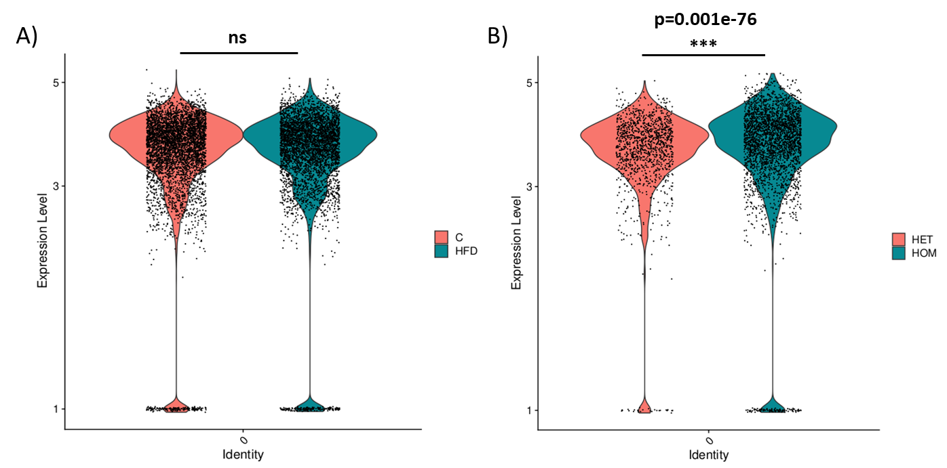

Figure 11. Violin plots showing gene expression for amyloid precursor protein in a) obese high-fat diet fed mice and b) obese and hyperglycaemic Db/Db mice.

## Discussion

Alzheimer’s Disease

Extending our original remit, we recognised early in the IM2PACT project that it would be difficult to meet our aim of understanding the gene expressed in the neurovascular cellular components without performing single nuclei sequencing. However, extracting the neurovascular component from brain tissue has proved challenging. Initial single cell atlases contained very few cells from the neurovasculature while recent high profile successes have only achieved ~50% enrichment of neurovascular cellular components. Our initial efforts were disappointing, achieving only ~5% enrichment but through IM2PACT innovation, we have developed a new state-of-art procedure separately delivering both parenchymal and neurovascular fractions form the same tissue, enriching to ~80%.

Sequencing 40 individuals (20 AD, 20 controls) we have laid out, as far as we are aware, the most detailed map of gene expression in the prefrontal cortex. We examined which cell types genetic risk of AD was likely to acting in by intersecting the genetic risk associated with loci across the genome with the cell type specific expression of genes within those loci but this analyses only confirmed an association of AD risk with parenchymal cell types, microglia as has been previously reported but also a novel association with a particular population of T-cells present in the paranchyma which needs further analytical follow-up. We did not observe an association with any specific vascular cell type. However, while we observed an expected reduction in neuronal cell types in the parenchyma in the AD samples, we unexpectedly also observed a reduction in the Trans Endo-to-Mural cell population which could reflect a reduction in the regenerative capacity of the tissue to repair microcapillary vessels. We observe modest gene expression changes in the neurovascular cell types during disease in comparison to greater changes in the parenchymal cell types, but nonetheless are able to show that expression of the three candidate transporter genes identified by the IM2PACT consortium is not affected in AD which maintains their candidacy.

Rodent Metabolic Disorder Models

A key finding from these studies in that there is an abundance more changes in the obese and hyperglycaemic Db/Db model compared to the obese high-fat diet fed model. This suggests that hyperglycaemia and the resulting physiological changes hyperglycaemia causes are fundamental in driving gene changes in endothelial cells in the brain. Obese high-fat diet fed mice show only 2 changes, Slc16a1 and Hmgcs2 (Figure 10). Slc16a1 is a transporter which is also known as monocarboxylate transporter 1. It is a proton coupled transporter which catalyses the movement of monocarboxylates including lactate and pyruvate. It is found on the luminal and abluminal membranes of brain capillary endothelial cells and can operate bidirectionally. Here, we observe an upregulation of Slc16a1 in our model of obesity, which could be as a result of altered energy regulation due to shift in fuel source from carbohydrate to fatty acids due to the high-fat diet. Cells may be trying to move monocarboxylates to try and balance energy dysregulation. Hmgcs2 is a mitochondrial enzyme responsible for catalysing the first reaction of ketogenesis, which provide energy from lipid sources. Upregulation of both these gene suggestions a shift in energy dynamics in brain endothelial cells towards using fatty acids as an energy source.

There are many more gene changes in the obese and hyperglycaemic Db/Db mice, therefore pathway analyses could be carried out (Table 2). The GO pathway analyses showed pathways involved in cell stress, cell death, immune responses, and metabolism, particularly pathways linked to lipid metabolism (Table 3). Interestingly, there was a cluster of genes related to the electron transport chain (e.g., mt-Atp8, mt-Nd4l, mt-Nd3, Atp5k) detected in the DAG analysis. These findings agree with previous experiments in Db/Db mice showing reduced respiration in ex vivo extracted brain microvessels, as well as in vivo experiments showing decreased exchange levels of oxygenated and deoxygenated haemoglobin.

Since there is a growing body of evidence that type 2 diabetes can increase the likeliness of developing Alzheimer’s disease, key genes related to the neurodegenerative disease were screened for. Expression levels of a key gene linked with Alzheimer’s diseases, amyloid precursor protein (App), did not change in obese high-fat diet fed mice (Figure 10a), however, increased in obese and hyperglycaemic Db/Db mice (Figure 10b). App is involved in the development of amyloid plaques. This suggests that type 2 diabetes, particularly hyperglycaemia, may drive the molecular underpinnings of Alzheimer's disease and should be explored further.

## Conclusion

We have delivered a novel state-of-the-art method to extract and sequence the neurovascular that has enabled a more complete analyses of the role of neurovascular cell types in Alzheimer’s risk, revealed changes in individual neurovascular cell types during disease and confirmed the expression of IM2PACT candidate transporters is unaffected during Alzheimer’s pathogenesis.

Obesity caused limited changes to gene expression in brain endothelial cells. Obesity with hyperglycaemia caused more pronounced changes including genes involved in expression networks, including microvessel structure and metabolism, alongside suppression in blood flow and worsened metabolic phenotype. Changes in genes linked to Alzheimer’s disease were also detected. This highlights that uncontrolled type 2 diabetes may be a key driver in the development of neurodegeneration through the effect of hyperglycaemia on the function of the blood-brain barrier.

## Repository for primary data

The first set of 20 samples (10 AD cases, 10 controls) are available from the NCBI’s Gene Expression Omnibus Datasets (https://www.ncbi.nlm.nih.gov/gds/) as Series GSE222007 “Single-nucleus RNA-seq of microvessel-enriched vascular cells and corresponding parenchyma from frontal cortex samples.” The second set of samples (included together here) are undergoing final QC and alignment and will be submitted and linked to the first set shortly.

Rodent data has not been submitted to a repository yet, however, once final data analyses have been completed, data will be submitted to an open access data repository, such as the Gene Expression Omnibus (NCBI – NIH) or Expression Atlas (EMBL-EBI).